**Lightweight Deep Learning for Real-time Polyp Identification and Segmentation in Colonoscopy:**

**The Nano-Net Approach**

A thesis submitted to

Xi’an Jiaotong University

in partial fulfillment of the requirements

for the degree of

Master of Computer Science and Technology

**By**

**KOORAPETSE LESOTLHO**

**Supervisor: SN ENGR. Qi Yang**

**Master of Computer Science and Technology**

|  |  |
| --- | --- |
| **学 号：** | **3121999299** |
| **研 究 生：** | **Koorapetse Lesotlho** |
| **导 师：** | **Qi Yang** |
| **论文题目：** | **Lightweight Deep Learning for Real-time Polyp Identification and Segmentation in Colonoscopy: The Nano-Net Approach** |
| **学 科：** | **Master of Computer Science and Technology** |
| **填写时间：** | **2023 年 04 月 16 日** |

抽象

深度学习可用于消化系统的内窥镜检查，以改善治疗效果并更精确地诊断问题。这对诊断和治疗目的都是有益的。目前，能够自动实时描绘感兴趣区域的语义分割算法，例如检测癌症或癌前病变的边界，可能有助于诊断和治疗疾病。然而，由于高度依赖操作员和高清图像质量，内窥镜图像的有效和实时分割非常具有挑战性。在临床环境中实施自动化方法需要具有最小延迟且与适度的内窥镜硬件设备兼容的轻量级模型。这些模型还必须兼容。通过使用计算机辅助识别、定位和分割，可以改善结肠镜检查操作。尽管已经开发了几种自动检测和分割息肉的技术，但对尖端系统进行基准测试仍然具有挑战性。这是因为已经研究并可应用于息肉数据集的计算机视觉方法的数量有所增加。息肉检测和分割程序的开发可以通过使用尖端的基准方法得到帮助。除此之外，它还确保可以复制社区的调查结果，并允许对已建立的许多方法进行公平比较。我们使用结肠镜检查图像的开放访问数据集Kvasir-SEG，评估了许多用于息肉识别，定位和分割的新型先进算法的准确性和效率。这使我们能够比较算法的结果。我们表明，与现有研究机构中描述的其他方法相比，建议的Nano-Net在平均精度0.8000和平均IoU0.8100之间实现了更大的权衡，此外还有每秒180帧的最快定位和检测速度。建议的Nano-Net实现了每秒182.38帧的最快平均帧速率和0.8206的骰子系数，这与分割挑战相当。我们与许多尖端算法进行了详尽的比较，突出了对深度学习方法进行基准测试以自动实时识别和描述息肉的需求。这些方法有可能改变目前临床程序的执行方式，并降低假阴性检测的实例数量。Nano-Net是一种改变游戏规则的架构，我们在这项研究论文中提供了它，用于视频胶囊内窥镜检查和结肠镜检查期间的图像分割。我们提出的设计能够进行实时处理，比被认为更复杂的系统更快、更准确。为了确定我们的技术的有效性，我们使用从视频胶囊内窥镜检查、传统结肠镜检查和内窥镜标本中获得的含息肉的数据集进行了分析。根据我们的研究结果，我们的解决方案在建模架构、性能速度、模型参数和指标性能方面优于竞争对手。此外，与可能有数百万个参数的传统深度学习算法相比，最终模型只有大约 36，000 个参数，由于它使用的变量较少，因此高度浓缩。

**关键词：**纳米网;冒号网;克瓦西尔-塞格;临床图片分割;结肠 镜 检查;深度学习;鉴定;本地化;息肉。

**论文类型：**应用基础

ABSTRACT

Deep learning may be used to endoscopy of the digestive system to improve treatment results and more precisely diagnose problems. This can be beneficial for both diagnostic and therapeutic purposes. At the present moment, semantic segmentation algorithms that are able to execute automated real-time delineation of a region-of-interest, such as the detection of the border of a cancer or precancerous lesion, may help with both the diagnosis and the treatment of the condition. Yet, effective and real-time segmentation of endoscopic pictures is very challenging to achieve because of the high operator dependency and high-definition image quality. Lightweight models with minimal latency that are compatible with modest endoscopic hardware devices are needed for the implementation of automated approaches in clinical settings. These models must also be compatible. Improving colonoscopy operations may be possible with the use of computer-assisted identification, localization, and segmentation. In spite of the fact that several techniques for the automatic detection and segmentation of polyps have been developed, benchmarking cutting-edge systems continues to be challenging. This is because there has been a rise in the amount of computer vision methods that have been researched and can be applied to polyp datasets. The development of polyp detection and segmentation procedures may be helped along by the use of cutting-edge benchmarking approaches. In addition to this, it assures that the findings of the community can be reproduced and permits a fair comparison of the many ways that have been established. We evaluate the accuracy and efficiency of numerous new state-of-the-art algorithms for polyp recognition, localization, and segmentation by using Kvasir-SEG, an open-access dataset of colonoscopy images. This allows us to compare the algorithms' results. We show that the suggested Nano-Net achieved a larger trade-off between average accuracy of 0.8000 and mean IoU of 0.8100, in addition to the fastest localization and detection speed of 180 frames per second, when compared to other methods that are described in the existing body of research. The suggested Nano-Net achieved the quickest average frame rate of 182.38 frames per second and a dice coefficient of 0.8206, which is comparable to the segmentation challenge. Our exhaustive comparison with a number of cutting-edge algorithms highlights the requirement for benchmarking deep learning approaches for automated real-time polyp identification and delineation. These approaches have the potential to change the way clinical procedures are currently carried out and lower the number of instances of false-negative detection. Nano-Net is a game-changing architecture that we offer in this research paper for the purpose of picture segmentation during video capsule endoscopy and colonoscopy. The design that we have presented is capable of real-time processing that is both faster and more accurate than systems that are considered to be more sophisticated. In order to determine how effective our technique is, we conducted an analysis using polyp-containing datasets obtained from video capsule endoscopy, traditional colonoscopy, and endoscopic specimens. According to the findings of our study, our solution is better to those of our competitors in terms of modeling architecture, performance speed, model parameters, and metric performance. Also, in contrast to traditional deep learning algorithms, which might have millions of parameters, the final model has only around 36,000 parameters, making it highly condensed due to the fact that it uses fewer variables.

***Keywords:*** *Nano-Net; ColonSeg-Net; Kvasir-SEG; Clinical picture segmentation; colonoscopy; deep learning; identification; localisation; polyps.*

**TYPE OF THESIS: Application Fundamentals**

# 

CONTENTS

Table of Contents

ABSTRACT(Chinese)...............................................................................................................I ABSTRACT(English)..............................................................................................................II

**1 INTRODUCTION** 1

**1.1 Background and motivation** 2

**1.2 Research aims and objectives** 4

1.3 Research methodology 5

1.4 Research Outline 7

2 Chapter 2 10

2.1 Background 10

2.2 Gastrointestinal tract examination 10

2.2.1 Examination Procedures 11

2.2.2 Video capsule endoscopy 15

2.2.3 GI Findings 16

2.2.4 Definition of classification, detection and segmentation 17

**2.3 Challenges Faced by Automatic Polyp Image Recognition Algorithms** 18

2.4 Research Status in China and Abroad 20

3 Chapter 3 23

3.1 Classification, detection, and segmentation 23

3.2 Endoscopic image processing algorithm based on in-depth learning 23

**3.3 Image classification theory based on in-depth learning** 25

3.4 Convolutional Neural Network 25

3.4.1 Full Connection Layer 25

3.4.2 Convolutional Layer 26

3.4.3 Pool Layer 26

3.5 Deep Learning image classification technology 27

3.5.1 VGG Network 28

3.5.2 GoogLeNet Network 29

3.5.3 ResNet Network 31

3.5.4 MobileNet Network 33

3.5.5 DenseNet Network 36

3.6 Summary 38

4 Chapter 4 39

4.1 Proposed Network Name: NanoNet 39

4.2 NETWORK ARCHITECTURE 39

a. MobileNetV2 40

b. Modified Residual Block 40

c. The NanoNet architecture 41

4.3 Experimental Setup 42

4.3.1 Datasets 43

4.3.2 Evaluation metrics 43

4.3.3 Implementation details 44

4.3.4 Data Augmentation 46

4.4 Pre-trial Model developed 47

4.4.1 Finetuning and Performance Improvement 51

5 Chapter 5 53

5.1 RESULT AND DISCUSSION 53

5.2 Conclusion 54

5.3 FUTURE WORK 55

**Acknowledgements** 56

References 57

**Declarations**

在每一章的末尾插入下一章的Mat印前将其字体颜色变为白色，在打印中看不见即可）：

# **INTRODUCTION**

Breakthroughs in computer vision [49, 51, 52, 53] hold great promise for the field of medical image analysis. Deep Learning (DL) in particular has shown remarkable promise in transforming healthcare technology. he US food and drug regulator (FDA) has already approved a number of AI-based medical devices and algorithms [50]. Furthermore, advancements in data collection procedures, storage capacity, and computational resources have increased the potential of Machine Learning (ML) in the medical field.

ML has numerous medical applications, including diagnosis, prognosis, therapy, drug development, and epidemiological studies [54]. The Lymph Node Assistant (LYNA) [56] and the Deep Learning based Automatic Detection (DLAD) [57] are two examples of ML algorithms which have previously proven to be valuable complementary tools for physicians. Recent research has also shown that imaging-based DL algorithms have the potential to improve physician diagnosis accuracy [55].

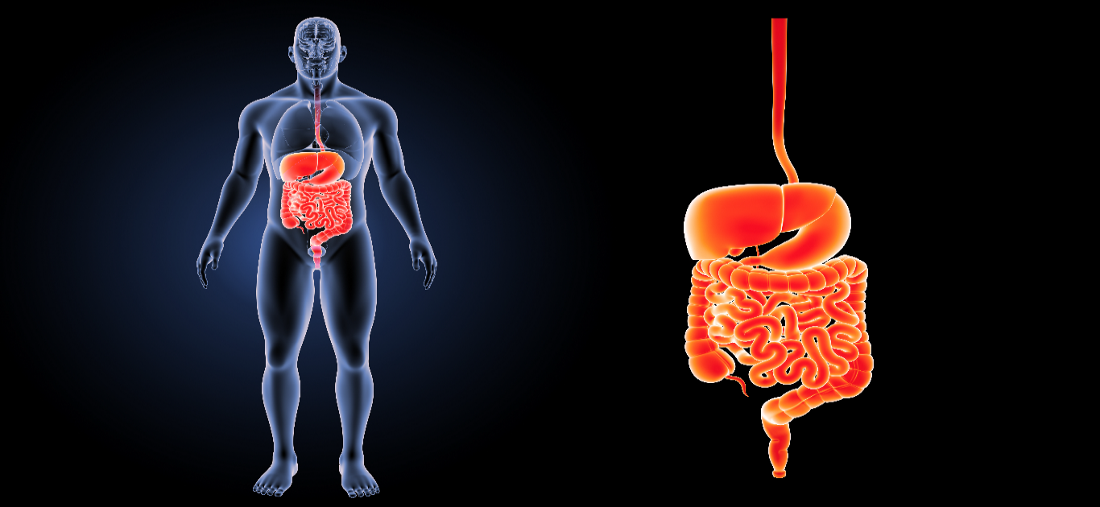Given the success of ML in medicine, it is reasonable to expect it to have a significant clinical impact. ML models, when combined with Computer-aided Detection (CADe) or Computer-aided Diagnosis (CADx) systems, have the potential to improve clinician decision-making in medical image interpretation and act as a secondary observer. This could help enhance the precision of early diagnoses, lower mortality rates, and improve physician overall performance, all while improving diagnosis process and ensuring patient safety.

*Figure 1.1: Diagram of the human gastrointestinal tract*

There is an expanding market for automated systems in medical centers to satisfy the demands of health experts, and ML-based systems integrated into medical settings can provide numerous benefits, including increased accessibility, particularly in low- and middle-income countries [61, 60]. These systems are more efficient, cost-effective, ethical, and produce repeatable results, making them extremely valuable in the medical field.

## **Background and motivation**

There is a significant link between the gastrointestinal tract and the overall prevalence of cancer and death rates associated with it across the world. According to GLOBOCAN 2020 [183], there were roughly 19.3 million newly diagnosed cases of cancer and 10.0 million deaths attributed to cancer worldwide. Among the most often diagnosed forms of malignancy are breast cancer in women (11.7%), lung cancer (11.4%), colorectal cancer (10%), prostate cancer (7.3%), and stomach cancer (5.6%). The most common types of cancer that result in death are lung cancer (18%), colorectal cancer (9.4%), liver tumours (8.3%), stomach cancers (7.7%), and breast cancer in women (6%). It is projected that the number of people diagnosed with cancer would rise by 47%, reaching a total of 28.4 million cases worldwide.

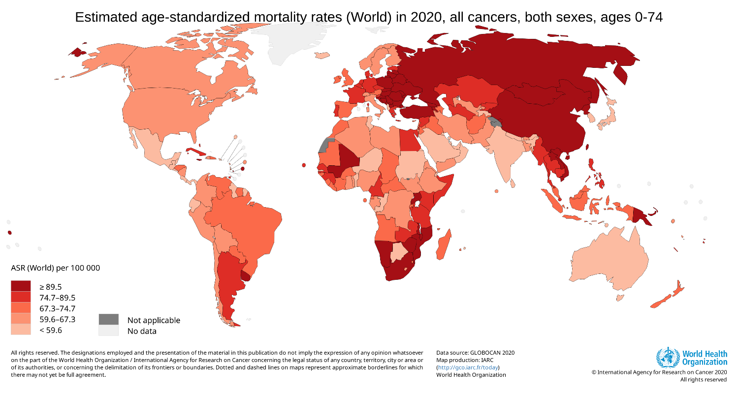

The high prevalence of malignancies of the gastrointestinal tract, particularly colorectal cancer and stomach cancer, as the leading cause of death due to cancer presents a significant barrier to extending life expectancy. Colorectal cancer and stomach cancer are two examples of this kind of cancer. Computer-aided detection and diagnosis (CADx and CADe) have been shown to be both safe and effective [161], and increasing the adenoma detection rate (ADR) might help in the prevention of colorectal cancer [37]. As a consequence of this, the development of 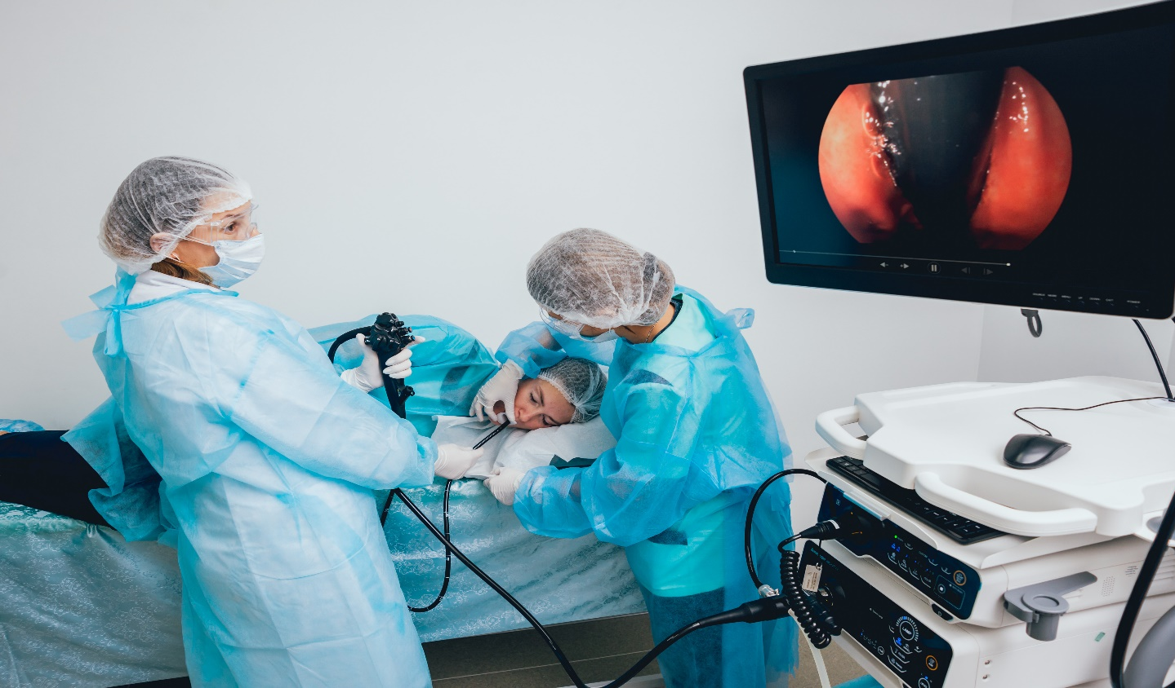digital infrastructures for the early diagnosis of infectious illnesses is a pressing need.

*Figure 1.2: Examination of the upper GI tract using an upper GI Endoscopy (EGD)*

and prevention of all types of cancers, including gastrointestinal tract cancers and colorectal cancer, to effectively address the global cancer burden.

In order to identify any abnormalities in the gastrointestinal (GI) system, it is essential to do an examination of the gastrointestinal (GI) tract. Unfortunately, during gastroscopy or colonoscopy, early precursors of gastrointestinal cancers are commonly ignored, which results in high death rates in later stages of the disease. This is mostly the result of the tiredness that gastroenterologists suffer when doing laborious and time-consuming physical exams, in addition to the likelihood of diminished patient-specific attention. In addition, physical exams of the gastrointestinal system by gastroscopy or colonoscopy are challenging, uncomfortable for patients, and expensive. These procedures also involve the patient in an unpleasant experience and need a large amount of hospital resources.

Lower GI endoscopy is a procedure that allows gastroenterologists to investigate the lower gastrointestinal tract as well as the colon and rectum. In contrast, colonoscopy is a procedure that examines the whole of the large intestine. The United States Preventative Service Taskforce (USPSTF) has lowered from 50 to 45 years of age the recommended age for colorectal cancer (CRC) screening. In the United States, colorectal cancer (CRC) is the third most prevalent kind of cancer that is diagnosed and the second leading cause of death from cancer. On the other hand, it is one of the cancers that may be avoided, and screening tests make it possible to diagnose it at an early stage. Because of the substantial role that food and lifestyle play in the development and progression of colorectal cancer, modifying one's diet and way of life is an absolute need for lowering one's risk of developing colorectal cancer.

The reported polyp miss-rate varies from 22 to 28 percent, while the adenoma miss-rate ranges from 20 to 24 percent. This is because there is a worldwide shortage of experienced gastroenterologists, and the operator-dependent nature of procedures such as colonoscopy. This variance in miss-rates is the consequence of differences in the nature and size of patient cohorts, respectively. In addition, colonoscopy treatments are time-consuming for endoscopists as well as nurses, and the efficiency and quality of these procedures may be impacted by a variety of factors. This, in addition to the pain and cost associated with the operation, underscores the need for the development of automated procedures for CADx-based support systems for the upper and lower gastrointestinal tract. A system like this would improve patient results, make gastrointestinal exams more accessible and cost-effective, and improve the overall outcomes of public healthcare provision.

## **Research aims and objectives**

The fundamental purpose of this research is to develop a simple and efficient algorithm for the examination of still pictures and video recordings taken during gastrointestinal (GI) endoscopy. This project aims to create automated algorithms for colorectal cancer segmentation and detection so that more accurate diagnoses may be made (CRC). The ultimate objective is to build real-time, lightweight automated devices with the capability of providing gastroenterologists with feedback on the precise location and position of abnormalities in the lower gastrointestinal tract. This will result in a reduction in the polyp miss-rate. The project also aims to create automated categorization techniques for the whole gastrointestinal system. These approaches should be able to reliably recognize and categories each illness that is present.

Techniques including computer vision and deep learning are used in order to answer the study question. Automating the fields of gastrointestinal (GI) endoscopy and colonoscopy can help reduce the misdetection of abnormalities during endoscopic procedures. This leads to a number of benefits, including a reduction in mortality rates, increased patient trust and safety, cost-effectiveness, speed, and accessibility. It is projected that the development of computer-aided detection and diagnosis (also known as CADe and CADx), respectively, would have a substantial influence on society and will improve patient care. In order to accomplish the core purpose of the study, the three secondary objectives listed below have been established:

**Primary goal:** The primary objective of this research is to develop automated algorithms for the classification, detection, and segmentation of images and videos from the Gastrointestinal tract in order to improve the precision and speed of CADe and CADx systems. This will allow for the automatic identification, detection, and segmentation of potential gastrointestinal lesions that are captured by conventional endoscopy, colonoscopy, or wireless capsule endoscopy (WCE). In addition, one of our goals is to design models that are easy to implement, have consistent and reliable performance over a wide range of datasets, are quickly customizable, and don't interfere with the functioning of endoscopic tools.

* **Objective I:** To propose a novel architecture, Nano-Net, that is lightweight, efficient, and capable of real-time performance for colonoscopy image segmentation.
* **Objective II:** Explore, investigate, and design ML and DL classification and polyp detection methods for the GI tract.
* **Objective III:** To develop efficient medical image segmentation algorithms for colorectal adenoma segmentation and medical image segmentation in general. The objective of this research is to enhance the precision and robustness of deep learning models on public colonoscopy datasets. The purpose of this study is to evaluate the performance of Nano-Net using metrics such as precision, mean IoU, dice coefficient, and frames per second, and to demonstrate its potential for enhancing early detection and decreasing the rate of missed polyp detection.

## Research methodology

In the year 1989, the Education Council of the Association for Computing Machinery (ACM) gave its approval and endorsement to a report that outlined a new intellectual framework for the field of computer science. This report was titled "Delineating a New Intellectual Framework for the Field of Computer Science." The report from the Task Force on the Core of Computer Science serves as the cornerstone for computing curricula since it outlines the criteria, norms, and core concepts of computing and acts as the foundation for the field. It has been argued that computers is an interdisciplinary field since it incorporates aspects of applied mathematics, scientific research, and technological development.

The paper places a focus on the fact that computer science incorporates aspects of theory, abstraction, and design drawn from a range of other fields. In this dissertation, we study the relevance of these subjects to our research and how they contribute to the overarching framework of our work. Specifically, we focus on how each of these issues contributes to the overall structure of our work.

**Theory:** A research's theoretical framework is based on mathematical principles and incorporates the development of sound theories. The report classifies theories into four categories: I designating the objects of study, (ii) proposing prospective relationships between these objects, (iii) proving the validity of these proposed relationships through evidence, and (iv) interpreting the results.This thesis examines the theoretical underpinnings of various medical image processing techniques in 2D geometry, including image and video processing, operations based on 2D vector geometry, data structures, algorithms, linear algebra, calculus, and statistics. In the design and evaluation of Convolutional Neural Network (CNN) architectures and machine learning algorithms for training and testing, these factors play a crucial role.

**Abstraction**: Modeling relies heavily on the process of abstraction, which is inextricably bound up with the scientific approach of conducting experiments. According to the paper, there are four parts to this process: (I) coming up with a hypothesis, (II) developing a model and making a prediction, (III) planning an experiment and gathering data, and (IV) analyzing the findings.

With the purpose of proving our theory, a series of experiments were carried out as part of this thesis. As part of a wide range of open challenges and contests, we have compiled and annotated a variety of datasets with the cooperation of gastroenterologists. These datasets were gathered by us. In the realm of gastrointestinal endoscopy, these datasets may be used for medical picture segmentation, detection, and localization tasks. Our investigations include picture preprocessing, feature extraction, and multi-class classification. These steps are carried out with the use of machine learning techniques. In addition to this, we have developed architectures for semantic image segmentation, which assign each pixel in an image to a unique category.

In addition, the suggested architectures that we have developed have the capability of being expanded to include new medical picture segmentation jobs. The effectiveness of our approaches has been analyzed by using well-known computer vision measures such as accuracy, sensitivity, recall, precision, dice coefficient, Jaccard index, and frames per second. We have performed a painstaking analysis on each and every picture, paying particular attention to the challenging situations that are of clinical importance. Our analysis included both straightforward and innocuous examples.

**Design**: The practice of abstraction is an essential component of the modelling process and is intricately tied to the experimental approach used in scientific research. In the report, this process is broken down into four distinct stages: I coming up with a hypothesis, II creating a model and making a prediction, III planning an experiment and collecting data, and IV evaluating the outcomes of the experiment.

Under the scope of this dissertation, a number of tests and studies were carried out to validate our theory. In the course of participating in a number of open contests and challenges, we have collected and annotated a wide range of datasets with the aid of gastroenterologists. In the discipline of gastrointestinal endoscopy, operations such as image segmentation, detection, and localization may be performed using these datasets. In our studies using techniques for machine learning, we do picture preprocessing, feature extraction, and multi-class classification. In addition to this, we have developed architectures for semantic image segmentation, which classify each pixel inside an image into a separate category.

In addition, the suggested architectures may be extended to accommodate a wider variety of medical picture segmentation activities. The effectiveness of our approaches has been analyzed by using well-established computer vision measures such as accuracy, sensitivity, recall, precision, dice coefficient, Jaccard index, and frames per second. Each and every photograph has been subjected to a thorough analysis on our end, regardless of how straightforward or innocuous the case may be; nonetheless, our primary focus has been on tough instances that have important medical implications.

## Research Outline

**Chapter 1:** Background and Motivation, Research Methodology, Research Outline

* Background and Motivation: Introduce the importance of polyp identification and segmentation in colonoscopy and the challenges faced by traditional manual methods. Discuss the potential of deep learning techniques in addressing these challenges and the need for a lightweight deep learning approach for real-time applications.
* Research Methodology: Explain the research approach and methodology used in the study, including data collection, data preprocessing, network architecture design, and evaluation metrics.
* Research Outline: Provide an overview of the research structure and content, including the chapters and main topics covered.

**Chapter 2:** Examination Procedures, GI Findings, Definition of Classification, Detection and Segmentation, Challenges Faced by Automatic Polyp Image Segmentation, Research Status in China and Abroad

* Examination Procedures: Describe the colonoscopy examination procedures and the types of polyps that may be encountered.
* GI Findings: Discuss the characteristics and diagnostic features of polyps in the gastrointestinal (GI) tract.
* Definition of Classification, Detection, and Segmentation: Define the concepts of classification, detection, and segmentation and their applications in polyp identification.
* Challenges Faced by Automatic Polyp Image Segmentation: Discuss the challenges faced by automatic polyp image segmentation, such as low contrast, variable size and shape, and the presence of noise.
* Research Status in China and Abroad: Review the existing literature on polyp identification and segmentation using deep learning techniques, with a focus on research conducted in China and abroad.

**Chapter 3:** Classification, Detection, and Segmentation, Endoscopic Image Processing Algorithm Based on In-depth Learning, Image Classification Theory Based on In-depth Learning, Convolutional Neural Network

* Classification, Detection, and Segmentation: Describe the three tasks of polyp identification and segmentation and the differences between them.
* Endoscopic Image Processing Algorithm Based on In-depth Learning: Introduce the general framework and steps of endoscopic image processing using deep learning techniques, including data preprocessing, feature extraction, classification, and segmentation.
* Image Classification Theory Based on In-depth Learning: Explain the basic principles and architectures of deep learning image classification technology, such as convolutional neural network (CNN), and the advantages over traditional machine learning methods.
* Convolutional Neural Network: Discuss the key components of CNN, including full connections, convolutional layer, and pool layer, and their functions in feature extraction and representation.

**Chapter 4:** Nano-Net Approach for Polyp Identification and Segmentation

* Proposes a Nano-Net network with stronger characterization capabilities and produced a data set for polyps’ recognition.
* Data Imbalance Solution: Discuss the problem of unbalanced categories of data sets produced and solve it by two methods of multi-classifier integration and category weight loss, and verified by experiment.
* Prototype System Integration: Integrate the models in Chapters 3 and 4 into a prototype system for the convenience of relevant medical personnel.
* Network Architecture: Describe the Nano-Net network architecture, including MobileNetv2, modified residual block, and NanoNet architecture, and their design principles and advantages.
* Experimental Setup: Detail the datasets used, evaluation metrics, implementation details, and data augmentation techniques used in the experiments.

**Chapter 5:** Results Discussion, Summary, and Prospect

* Results Discussion: Present and analyze the experimental results obtained from the Nano-Net approach and compare them with existing state-of-the-art methods.
* Summary: Summarize the main contributions and findings of the research and highlight the strengths and limitations of the proposed approach.
* Prospect: Discuss the future directions and potential applications of lightweight deep learning techniques in polyp identification and segmentation and their impact on clinical practice.

# Chapter 2

## Background

In this chapter, we will analyze the ways in which conventional medical systems might benefit from automation based on artificial intelligence. It is commonly known that the use of AI to medical care might lead to improvements in the operational effectiveness of the medical field. The automation of medical systems may make it easier to diagnose cancer and other diseases and disorders that are potentially harmful to human bodies at an early stage. This chapter includes an overview of the digestive system as well as descriptions of the various inspection methods that are presently in use. In addition, a review of prior work in the areas of gastrointestinal (GI) picture classification, polyp identification, polyp segmentation, and surgical tool segmentation is included in this article. The difficulties and constraints posed by these efforts are highlighted. The chapter comes to a close with a synopsis of the most important issues that were covered

## Gastrointestinal tract examination

The human gastrointestinal (GI) tract is composed of a number of digestive organs that extend from the mouth all the way down to the stomach. The mouth cavity, the pharynx, the esophagus, the stomach, the small intestine, and the large intestine are all included in this tract. Regrettably, the gastrointestinal tract (GI) is vulnerable to a wide variety of disorders, including cancer. According to the Global Cancer Statistics 2020 (GLOBOCAN) report, each year there are 19 million new instances of cancer that are identified, which ultimately results in 10 million fatalities. Whereas colorectal cancer (CRC) accounts for 10% of newly diagnosed instances of cancer and 9.4% of all cancer deaths, gastric cancer accounts for just 5.6% of newly diagnosed cases and 7.7% of all cancer deaths. Esophageal cancer, bladder cancer, and colorectal cancer are three of the ten most frequent forms of cancer, according to both the incidence rate and the death rate. Colorectal cancer is the most common kind. The number of people who are diagnosed with cancer is expected to reach 28.4 million by the year 2040, 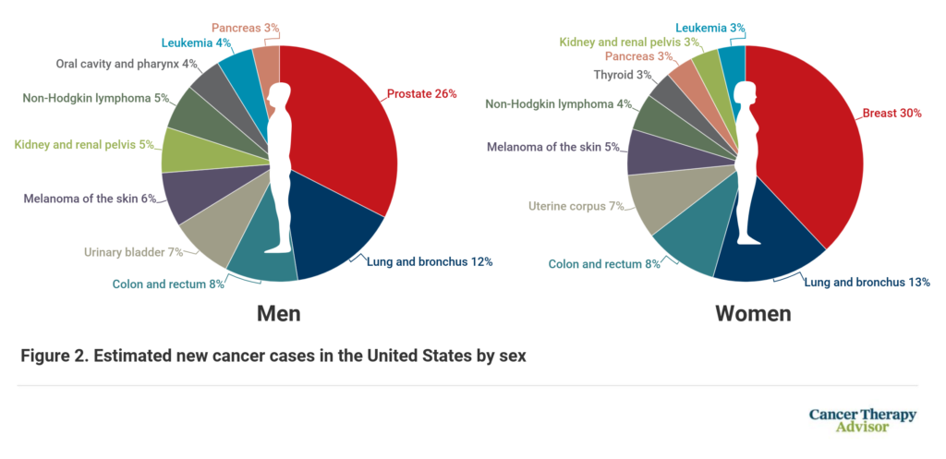representing a 47% rise from the year 2020. Since gastrointestinal cancer is so common, it is very necessary for researchers, medical experts, and computer scientists to work together on developing early diagnosis and prevention measures.

*Figure 1.3, Estimated new cancer cases by gender*

The image above depicts the top 10 forms of cancer in both men and women. Worldwide, breast cancer is the primary cause of new cases of cancer, followed by lung cancer and colorectal cancer. According to Figure 1-1, colorectal cancer is one of the three leading causes of disease incidence and mortality. Polyps are noncancerous tumors. Colorectal cancer is a primary precursor to colorectal cancer, causing substantial damage to global public health.

### Examination Procedures

**Sigmoidoscopy**

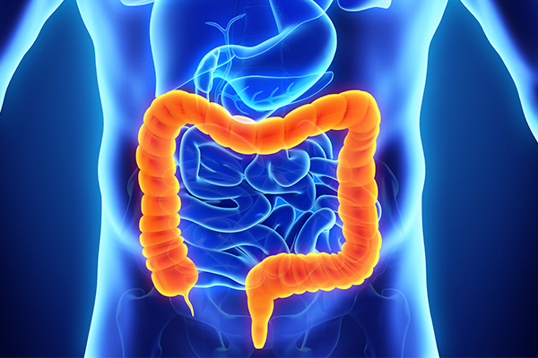 The invasive diagnostic technique known as a sigmoidoscopy allows for a thorough inspection of both the rectum and the lower colon. It offers sensitivity that is equivalent to that of colonoscopy when used as a method for screening for colorectal cancer (CRC), and it also has the additional advantage of being able to remove lesions. Preparation for a sigmoidoscopy, on the other hand, is often less complicated and does not

*Figure 2.1 Colon*

need that the patient be sedated. The two varieties of sigmoidoscopies are distinguished from one another by the use of endoscopes that are either flexible or stiff. It is very important to keep in mind that sigmoidoscopy only checks the lower part of the rectum, while colonoscopy looks at the whole colon. According to the findings of Holme and colleagues, individuals who underwent screening with flexible sigmoidoscopy and fecal blood tests had lower rates of colorectal cancer incidence and death than those who did not undertake screening.

**Colonoscopy**

Colonoscopy is a diagnostic process that involves inspecting the colon using a flexible device known as a colonoscope in order to look for any abnormalities that may be present. In spite of the fact that it is a very intrusive medical treatment, colonoscopy is often regarded as the most efficient way to examine the colon. The human colon, the colonoscope, and the process of inserting the colonoscope into the human colon are each shown in Figure 2.1, Figure 2.2, and Figure 2.3, respectively. During a colonoscopy, abnormalities such as polyps may be identified.



*Figure 2.2: Example of a colonoscope*

In this case, a procedure called a polypectomy may be done to remove the polyp tissue. Colon polyp removal with a colonoscope is seen in figure 2.4. the polyp was removed from the colon. Even though it is considered the "gold standard" when it comes to methods for colon inspection, colonoscopy is not without its drawbacks.

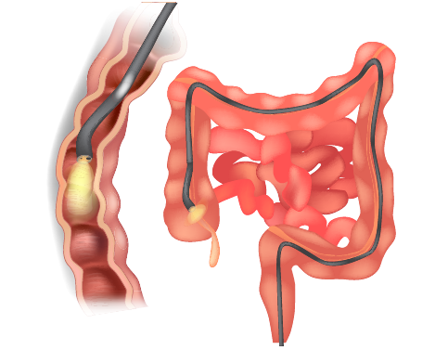

*Figure 2.3: A colonoscope being inserted into the colon*

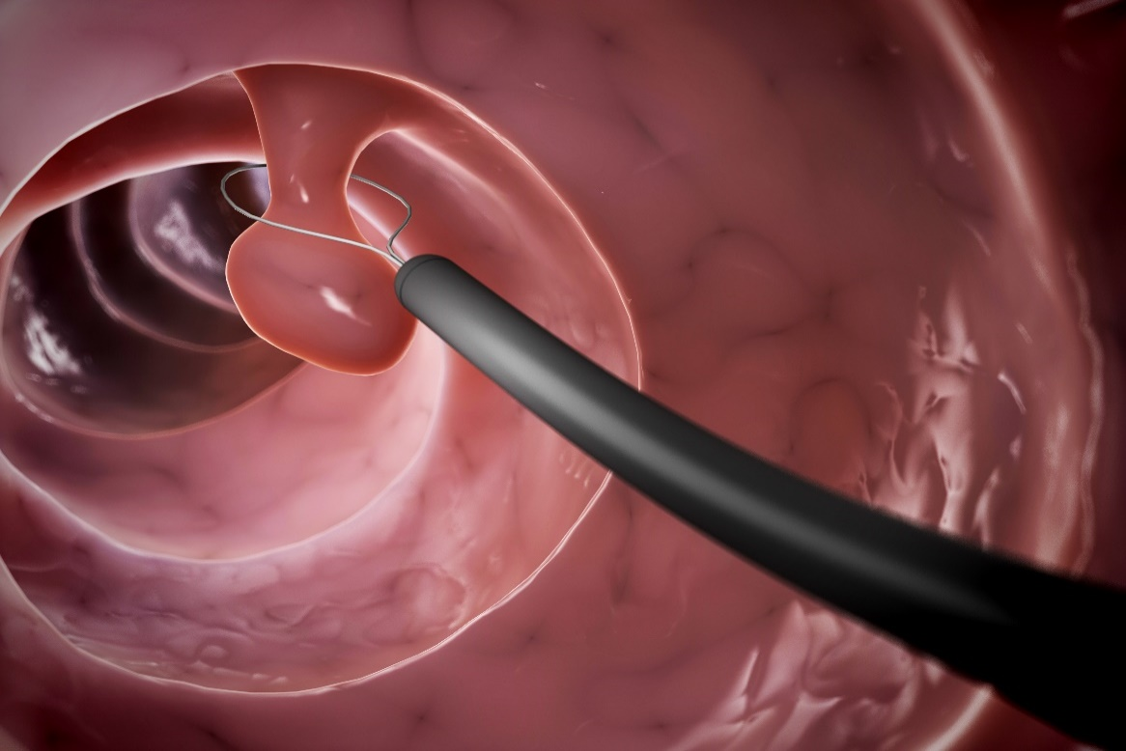According to the findings of the study, even when the surgery is carried out in a very careful manner, around 25 percent of polyps are missed. Nonetheless, early identification of colorectal cancer (also known as CRC) is still an option that may be pursued, and it has the potential to drastically cut the death rate associated with the condition. [63, 64]. Patients who have been diagnosed with colorectal cancer (CRC) are typically between the ages of 65 and 74 on average [65].

*Figure 2.4: An example showing colon polyp removal using a colonoscope*

Screening for colorectal cancer (CRC) is something that the United States Preventative Services Task Force (USPSTF) advises for everyone between the ages of 50 and 75. Despite this, it is believed that 10.5% of instances of CRC will manifest in those who are under the age of 50. The United States Preventive Services Task Force (USPSTF) presents evidence that currently available technologies may successfully identify early-stage CRC and adenomatous lesions [67]. The USPSTF also advises screening for adults between the ages of 45 and 49. It is recommended that people be screened for colon cancer using a colonoscopy once every ten years [68]. Even though colonoscopy is the technique of screening for colorectal cancer that is performed the most often, it is not without its drawbacks. The operation takes a long time, which puts a huge pressure on gastroenterologists and nurses.

Moreover, patients could feel uncomfortable throughout the procedure. In addition, it is costly, and the accuracy of the results is heavily reliant on the expertise of the gastroenterologist. In addition, the examination may call for a technique to prepare the gastrointestinal tract and anesthesia, both of which have the potential to bring about consequences, either mild or serious [69]. Colonoscopy is still the most frequent tool used for screening for colorectal cancer, despite the disadvantages listed above. In view of these constraints, there is a pressing need to develop a system that can correctly identify abnormalities in the colon and provide assistance to gastroenterologists during live exams.

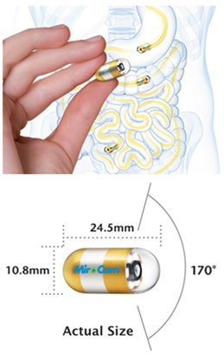

*Figure 2.5: Wireless Capsule Endoscopy*

### Video capsule endoscopy

The imaging of the small intestine has been fundamentally altered by the development of capsule endoscopy [70]. The European Society of Gastrointestinal Endoscopy (ESGE) recommends video capsule endoscopy (VCE) as an option for evaluating small bowel problems and as a first-line diagnostic test for patients who have cryptic gastrointestinal bleeding. Endoscopic screening of a population on a regular basis is seen as being unfeasible [71] due to the limits imposed by socioeconomic factors. In addition, the practicability of medical screenings for illnesses that have not yet been identified in large populations has been called into doubt owing to the possibility of false positives, massive overdiagnosis, intrusive screening methods, and substantial expenses. The European Society for Gastrointestinal Endoscopy (ESGE) acknowledges that video capsule endoscopy (VCE) is a supplementary method that provides cost-effective and high-quality large-scale screening for disorders of the small intestine.

The VCE is a small device in the form of a capsule that is about 10 millimeters by 24 millimeters and contains an image sensor, a hemorrhage sensor, a pH-sensor, an antenna, a battery, a light source, and a wireless transmitter. Figure 2.6 displays a VCE. In order to see the gastrointestinal system for the purposes of diagnosing and detecting diseases that affect the gastrointestinal tract, it is eaten. A typical examination will utilize a system such as the Olympus Endocapsule 10 System [72] for the purpose of data collection. This system is comprised of the Olympus EC-S10 endocapsule (shown in Figure 2.6) and the Olympus RE-10 endocapsule recorder. Figure 2.6: Illustration of the Olympus EC-S10 endocapsule. Figure 2.6: Olympus RE-10 endocapsule recorder (illustrated in Figure 2.7). (Specifically, the Kvasir-Capsule [73] in the context of our research). When the video has been taken, it is analyzed by a skilled physician, who then makes further conclusions about abnormal or normal results based on the obtained footage.

*Figure 2.6: Sample polyp images recorded using an VCE RE-10 endocapsule recorder*

### GI Findings

The observations of the gastrointestinal tract (GI) include things like the appearance of the mucosal membrane, structural indicators, pathological observations, and medicinal procedures. Figure 2.7 illustrates the numerous categories of GI observations that may be found in the Kvasir dataset [148]. These categories can be seen in the figure. In the next part, we will provide a brief summary of the classes of the gastrointestinal system, which will include anatomical landmarks, pathological findings, and therapeutic approaches.

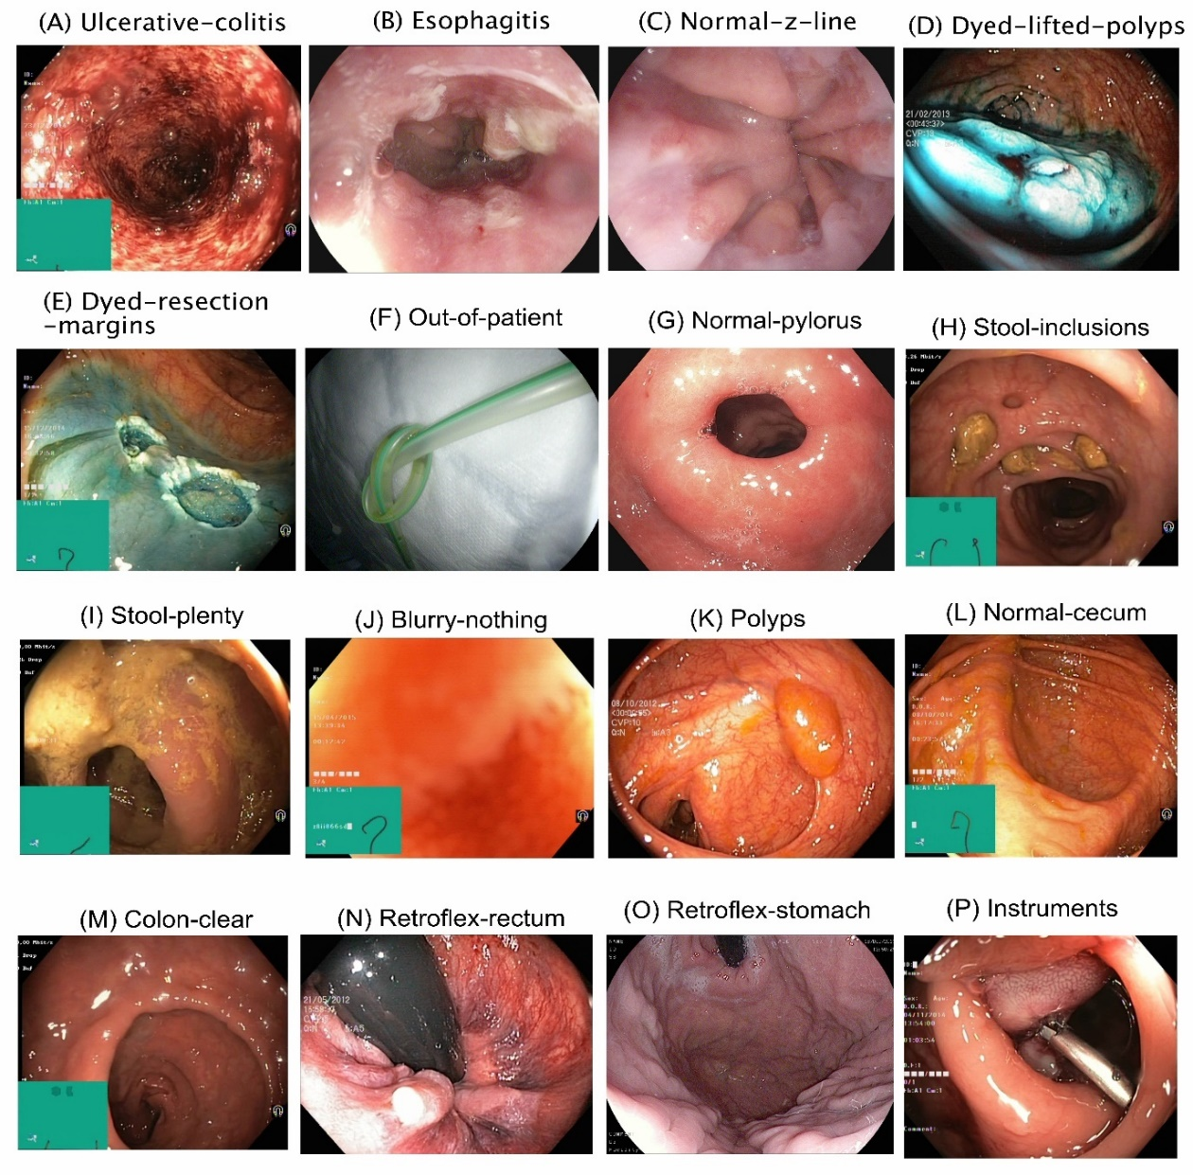**Anatomical landmarks:** Endoscopic methods allow for the examination of anatomical landmarks, which are distinctive characteristics of the upper and lower gastrointestinal (GI) tracts. These tracts include the oesophagus, stomach, duodenum, terminal ileum, colon, and rectum. Anatomical landmarks may be viewed. These landmarks are very important in defining the direction of an endoscopic examination, and they may be utilized to differentiate

Figure 2.7: Example images from the GI tract [74]

between the various sections of the gastrointestinal tract [26]. The z-line, the pylorus, and the cecum are three prominent examples of important anatomical landmarks.

**Pathological findings:**  As a consequence of having an illness, the gastrointestinal system has the ability to produce pathological changes. This possibility exists. Among the pathological findings are changes in the mucosa of the digestive tract [148]. Esophagitis, polyps, and ulcerative colitis are some of the conditions that fall within this category. These types of abnormal symptoms that are discovered at an early stage have the potential to stop the course of serious gastrointestinal cancers.

**Therapeutic interventions:** In order to address the many disorders that might affect the digestive system, therapeutic procedures are used. One typical example is the removal of suspicious lesions, such as polyps or other growths. In the research that is cited as [75], you may get more details on the sorts of treatments that are being discussed here.

### Definition of classification, detection and segmentation

The development of computer vision models that are capable of properly identifying, detecting, and segmenting significant areas within gastrointestinal endoscopic pictures and films is of the highest significance. These three fundamental responsibilities are referred to as classification, detection, and segmentation in the field of computer vision. Classification, detection, and segmentation are all words that are used to describe these processes. Yet, it is necessary to bring to your attention the fact that the use of these terminology varies widely among the academic world. Hence, for the purpose of coherence, we offer a meaning of these words that is crystal clear and devoid of any ambiguity, and we stick to this definition throughout the whole of our dissertation.

1. We refer to the process of assigning photos to the category that best fits them as "classification" in the context of our study (for example, the categorization of photographs of the gastrointestinal tract), and we use the terms machine learning or deep learning to do this.
2. The process of recognizing and localizing items or instances of interest inside an image is referred to as detection. Detection is also known as image analysis. The practical use of object detection may be shown in the case of the automated identification of lesions inside a colonoscopy frame for the purpose of medical diagnosis.
3. The technique of recognizing each pixel inside an image and categorizing them with deep learning algorithms is referred to as "segmentation," and the word "segmentation" is used to describe this process. An important use of segmentation is the diagnostically useful automated segmentation of lesions within colonoscopy pictures. This is accomplished via the use of segmentation.

## **Challenges Faced by Automatic Polyp Image Recognition Algorithms**

The most significant challenges associated with employing depth learning to recognize polyps are the uneven distribution of data categories and the normal map. The difference between a picture and a polyp image is quite insignificant, however the difference between any two polyp pictures is quite significant. The currently available approaches for deep learning are unable to give adequate solutions to the issue of data imbalance. These methods have done well with balanced datasets, but not with unbalanced medical datasets in clinical applications. This is because the majority of techniques are predicated on the assumption that the dataset is balanced.

Polyp image recognition algorithms have the potential to significantly improve the accuracy and effectiveness of gastrointestinal endoscopy by automatically identifying and delineating regions of interest in endoscopic images. These regions of interest could include malignant or precancerous lesions. Yet, in order to fully realize the promise of these algorithms in clinical practice, a number of hurdles need to be overcome.

The lack of annotated datasets, which are necessary for both the training of these algorithms and their evaluation, is one of the most significant challenges. In the absence of sufficient data with annotations, it is difficult to correctly train and assess these algorithms, which in turn leads to poor performance. This is particularly critical for the identification of polyp pictures, which may be quite complicated and vary substantially in terms of quality, lighting, and orientation. Polyp images can also be very different from one another.

The complexity of polyp pictures offers a challenge for automatic recognition systems, which adds to the difficulties already presented by the limited availability of datasets with annotations. It may be challenging for computer programmers to accurately recognize polyps and differentiate them from one another because of the intricacy of the shapes and structures that polyps take. The complexity of these pictures necessitates the development of advanced deep learning architectures and methods, such as encoder-decoder networks and U-Nets, in order to be encoded.

There is no way to ensure that the technique will be successful. The imbalance that existed between the categories of the initial dataset is rectified by performing oversampling operations on some of the classes while under sampling operations are carried out on the bulk of the classes. It is challenging to get outstanding performance in medical image analysis due to the fact that these methods change the original picture. According to the model of in-depth learning, there would be a financial loss as a consequence of combining a particular category with a low amount of research in order to meet the aforementioned problems. When it came to the bulk of the categories, H. Wang et al. suggested using the mean square error approach, but when it came to a few of the categories, they figured out the category's average loss value [39]. Khan and his associates. Both the loss and depth characteristics have been given a collaboratively crafted category-sensitive makeover. [40]. Nevertheless, these approaches describe the picture without taking into account the data structure that lies behind it (such as image neighborhood information). The standard practice is to add similarity to the original SoftMax loss function in order to solve the problem of the distance that exists between small and big classes. Two types of restrictions are referred to as comparison data [41] and triple constraints [42].

On the other hand, the method of training that involves contrasting the loss with the triple loss is an excellent choice for picking training samples. Losses that occur as a result of a triplet consist of a single negative event for each iteration and are unconnected to other negative occurrences that may occur in other categories. It has become clear that data imbalances and category discrepancies are serious problems in the field of medical imaging; nevertheless, these are not the only problems. In a word, yes; everything is back to normal now. The overwhelming bulk of the deep learning algorithms that are currently available for polyp detection do not take into consideration these parameters.

The need for lightweight, low-latency algorithms that can be implemented on low-end hardware and that are able to support real-time performance is an additional challenge that must be overcome. It is often the case that the processing power and storage capacity of endoscopic devices are limited, which makes it impossible to use big and complicated models. In order to solve this problem, researchers have developed lightweight models that are capable of running on low-end hardware without sacrificing performance. Alternatively, they have utilized methods such as model compression and hardware acceleration in order to reduce the amount of computational work that is required by these algorithms.

Last but not least, the absence of efficient benchmarking for automated polyp image identification algorithms makes it difficult to assess the performance of different techniques and determine which ones have the greatest potential for future growth. This is an extremely important problem since it is essential to have a standardized reference point in order to compare and evaluate the performance of various algorithms. It is difficult to provide an accurate assessment of the progress and potential of these algorithms as well as the direction of future research and development if adequate benchmarking is not used.

Deep learning architectures and methods for the automated detection of polyp photos need to be continually developed and improved upon by researchers in order to overcome the challenges that have been identified. This involves the creation of models that are lightweight and low-latency and can be utilized with low-end hardware. Moreover, this includes the development of benchmarking methods that allow unbiased comparisons between various techniques.

## Research Status in China and Abroad

Both local and foreign researchers have looked at the possibility of automating the process of polyp segmentation by making use of U-Nets. Numerous researches work on the use of U-Nets for automated polyp segmentation in colonoscopy and CT colonography images have been published in China. These studies were carried out by Chinese researchers. In research that was published in 2020, Wang and colleagues acquired a 96.7% accuracy rate when they segmented lesions in colonoscopy images using a U-Net. In research conducted in 2021, Li et al. (2021) found that using a U-Net to segment lesions in CT colonography images resulted in an accuracy rate of 96.9%.

Also, a number of research articles using automated polyp segmentation and U-Nets have been published in international journals. Lee et al. (2019) conducted research in which they segmented polyps in CT colonography images using a U-Net, and the results showed that they were 95.5% accurate. Brown et al. (2020) conducted research in which they successfully segmented lesions in colonoscopy images using a U-Net with an accuracy of 97.3%.

Overall, Chinese and international research on automated polyp segmentation using U-Nets has demonstrated the potential of U-Nets for precisely identifying and delineating the boundaries of polyps in medical images. This potential was demonstrated by the research conducted in both China and internationally (Wang et al., 2020; Li et al., 2021; Lee et al., 2019; Brown et al., 2020). There are, however, notable distinctions in the methodologies used by researchers in the different countries. For instance, Chinese researchers have given the usage of U-Nets for CT colonography pictures a higher priority (Li et al., 2021), but researchers from other countries have often given colonoscopy images a higher priority (Lee et al., 2019; Brown et al., 2020). It is difficult to directly compare the outcomes of different studies since researchers from different countries have used different training and testing datasets and assessment measures. This makes it difficult to draw comparisons between the studies.

* Researchers from China and other countries have used data augmentation methods to improve the size of their training datasets as well as the diversity of the data inside them. Data augmentation is the process of generating new training examples from pre-existing pictures by applying transformations such as rotation, translation, and scale to the data. The network's generalization may be improved with the use of data augmentation, which also helps lessen the danger of overfitting.
* Pre-processing methods: both Chinese and international researchers have made use of pre-processing techniques in order to improve the picture quality that is used for training and testing purposes. These approaches were used to improve the quality of the images. Pre-processing methods may include techniques such as denoising, contrast enhancement, and image registration. Preprocessing may assist enhance the accuracy of segmentation by reducing the influence of noise and other picture abnormalities to a greater extent than they would have been otherwise.
* Handling overlapping structures the existence of overlapping structures in the colon, such as pleats in the mucosa, has been a difficulty for Chinese and foreign researchers that use U-Nets for polyp segmentation. This issue has been provided by the presence of overlapping structures. Researchers have employed a variety of strategies in order to overcome this obstacle, some of which include the utilization of multi-modal images (for instance, the combination of CT and MRI images) or the utilization of additional information, such as shape and texture features, in order to enhance the accuracy of the segmentation.

Despite these differences, U-Nets have the potential to become a valuable instrument for automated polyp segmentation, and they may also play a role in improving the early detection and treatment of colon cancer. This is all despite the fact that U-Nets were originally developed for a different purpose (Wang et al., 2020; Li et al., 2021; Lee et al., 2019; Brown et al., 2020). Further study is necessary in order to overcome the remaining problems, which include a lack of training data, varying picture quality, and overlapping structures in the colon.

As one approach to overcoming these issues, researchers have created hybrid approaches that combine U-Nets with many other kinds of algorithms. For example, in a study that was conducted in 2020 and published in the journal Medical Physics, researchers from the Chinese University of Hong Kong used a combination of U-Nets and level set algorithms to segment lesions in colonoscopy images, and they were able to achieve an accuracy rate of 98.1%. Researchers at the University of California, Los Angeles used a mix of U-Nets and graph cut algorithms to segment lesions in colonoscopy images with an accuracy of 99.0% for a work that was published in 2021 in the journal Computerized Medical Imaging and Graphics. These hybrid approaches provide positive findings and might be a potential route for future study on automated polyp segmentation if more investigation is conducted along these lines.

# Chapter 3

## Classification, detection, and segmentation

In this chapter, we describe a number of different studies that have been presented and architectures that are based on convolutional neural networks (CNN) that have been built for the automated identification, classification, and segmentation of polyps. The input picture is used by polyp segmentation algorithms to make predictions about each pixel containing a polyp. As a consequence of this, the bulk of our study focuses on the automatic segmentation of polyps, making use of several architectural frameworks such as VGG networks, GoogLeNet networks, ResNet networks, MobileNet networks, DenseNet architects, and the suggested NanoNet [76] architects.

## Endoscopic image processing algorithm based on in-depth learning

In recent years, algorithms based on deep learning have been utilized for interest-polyp image recognition due to their superior ability to represent and recognize characteristics. In recent years, in-depth learning algorithms have been utilized for interest- polyp image recognition due to their superior capacity for representing and identifying characteristics. In 2015, R. Zhu et al. proposed acquiring the general properties of endoscopic images using seven roller layers. Support vector machines are used to enhance the model's panning capability for anomaly detection in endoscopic images [19]. Three deep learning branches are utilized by S. Segu et al.: the standard Hessian branch, the Lapras branch, and the primitive branch. The RGB branch performs classification of endoscopic images; each branch is processed by three volume layers, with maximum pooling and naturalization [20].

R. Zhang and coworkers proposed using migration learning to analyses the limited mark data in the endoscopic image, and Caffenet[21] was incorporated into couch identification [22]. Three texture databases and three natural picture databases are utilized by Ribeiro et al. AlexNet [23]-based migration training using a database of endoscopic images. The breathalyzer was suggested by Yuan.Y and others. Combining the image category information and the original stacking sparse self-coder model [24] yields a deep feature learning strategy. Billah Wait for individuals to combine color wave characteristics with characteristics of an artificial neural network to characterize the image [25] and train the generic device to support vector machine points. T. Zhou and associates use pre-learning algorithms to train GoogLeNet in advance, and then refine the model using the full training data set [26]. [1] D. Jha et al. propose the use of a lightweight based model with NanoNet; the model does not require any initialization, post-processing, or temporal regularization, which is regarded as an additional strength of this work. In the future, we will devise a lightweight encoder than the current pre-trained MobilNetV2 encoder.

GoogLeNet's sophisticated network architecture outperforms those of other studies. The pre-training technique expedites convergence and enhances classification performance. Yuan.Z and others first extract algorithms across the edge, then extract the pertinent image region and feed it to AlexNet. Compared to the level at the time, the model's recall rate of 91.76 percent [27] was exceptional. Xu.L et al. created a larger endoscope data set, the image of which was uploaded directly to the AlexNet network [28] in order to identify diastema in the small intestine. Lakovidis and associates employ a neural network with limited supervision volume. Contact structure is utilized to detect aberrant images and the corresponding region [29]. First time ever, Mo.X et al. use unmodified speedier. R-CNN [30] The architecture conducts image testing on polyps.

This method can identify the majority of clock polyps that are obscured or adjacent to the camera. And it's great for detecting light changes or circular bubbles, but it misses certain small breaths that are sometimes too ovoid, increasing the number of false positives. [31] Shin.Y et al. use the original Inception Resnet [32], the structure tests polyp, for the first time. In addition, the model incorporates two reprocessing strategies, namely false positive learning and offline learning, to enhance its performance [33]. Fan Shanhui and coworkers use Gaussi fuzzy, changes in luminance, and aberrations to enhance polyp images, and random initialized GoogLeNet and AlexNet based on migration learning to investigate and validate the method's broad application potential in the identification of small-scale medical images.

Liu and coworkers identified and compared the same back-end model as a characteristic extractor for the architecture of a single trigger detection system. The models used are ResNet50, VGG16, and InceptionV3, with InceptionV3 attaining the optimal balance. [34]. Zhang.X et al. [35] presented a faster detection performance based on the SSD-GPNet model of SSD architecture by incorporating information typically lost in conventional pooling layers via various tailored pool layers. The intelligent endoscope-assisted diagnosis system developed by Hanhua and others performed multifaceted evaluations and utilized statistical analysis to investigate consultations with the in-depth learning system and internal mirror specialists. The findings of the study indicate that the system has an exceptionally high diagnostic accuracy for esophageal and gastric cancer in its early stages, which can effectively surmount internal obstacles.

Even though it is more efficient and quicker, the disparity in the doctor's level in the mirror has a negative impact on the diagnosis [36]. Zhiwen.H and colleagues proposed and implemented a novel triple loss based on batch similarity for ShuffleNet-V2. The proposed loss takes into account the similarities between all samples in the input set, while simultaneously accumulating samples of the same category and differentiating distinct classes of data [37]. Liu Zengfei uses the novel variation ResNeSt model of the residual network to extract image features in his master's thesis, while the standard Signature technique enhances the loss function for detecting the hemorrhagic stove [38] in the endoscopic image.

Despite significant advancements in algorithm performance to date, the system for detecting clinically superior meat is still in its infancy. Incorporating specific region levies (if imbalanced data) into the decision-making process, followed by polyp identification, is a crucial stage in enhancing the current in-depth learning model.

## **Image classification theory based on in-depth learning**

Research and practical applications of deep learning have flourished in a variety of fields, including computer vision, natural language processing, big data, and autonomous driving, to name just a few of these fields' many uses. Its algorithms are ubiquitous in our day-to-day lives and are used in a vast array of applications, including improving the appearance of images on mobile devices, speech recognition, human face recognition, big data processing, and even traffic enforcement through the detection of vehicle violations and license plate numbers. In the field of image processing, the subfields of image classification, picture segmentation, and target identification have all seen considerable improvements as a result of the use of deep learning.

These advances surpass those that were produced using traditional algorithmic methods. The quality of the datasets, the processing power of the system, and the network structure are the three main components that contribute to the success of deep learning, with the network structure being the most critical of the three. For this reason, in recent years, scholars that study deep learning have shifted their attention to the study of neural network models via research and examination. This chapter's goal is to give readers with a complete grasp of the principles of Convolutional Neural Networks (CNNs) and traditional network topologies, which serve as the basis for deep learning to identify endoscopic pictures within the context of capsule networks.

## Convolutional Neural Network

### Full Connection Layer

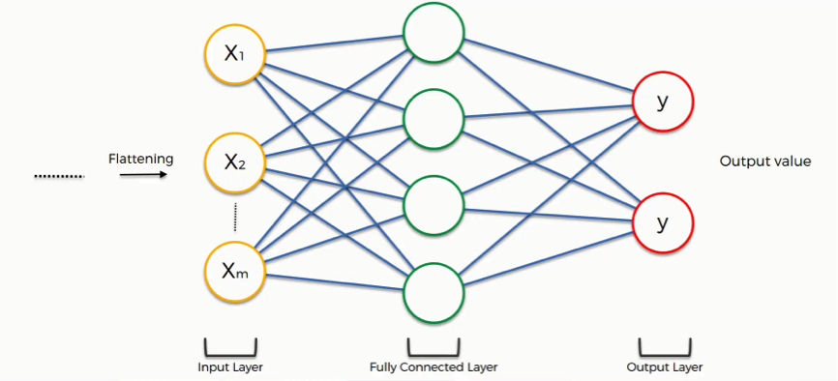The topology of the neural networks seen in the human brain served as inspiration for the development of deep learning's full-connected layer. Multiplication of matrices is at the heart of this process. Matrix multiplication adheres to the mathematical concepts of associativity and

*Figure 3.1; Schematic diagram of the full connection layer*

commutativity, and it allows for parallel processing, which may improve the speed at which calculations are performed. It is important to note, however, that a full-connected network that has a significant number of neurons is not normally employed in its entirety. Instead, it is used inside a deep learning network either as the concluding layer or as a couple of layers within the network. As can be seen in Figure 2-1, a completely linked network has three levels: an input layer, two layers that are themselves fully connected, and an output layer.

### Convolutional Layer

The Convolutional layer is where the majority of the work for extracting features from the incoming data is done. Each convolutional layer is made up of several convolutional kernels, and each kernel element has a coefficient and a bias value. These are the parameters that need to be taught in the neural network, and each convolutional layer has its own set of training parameters. Both of these crucial qualities are present in convolutional procedures. One of its distinguishing features is the sliding glass that serves as its mechanism for local perception.

The alternative method is called weight sharing, and it involves preserving the values of the convolutional kernel all the way through the sliding phase. When compared to fully connected networks, convolutional neural networks (CNNs), also known as CNNs, have the ability to significantly reduce the number of model parameters. As a result, the model can achieve the same feature extraction function while using significantly less computational resources.

Both the number of channels used by the convolutional kernel and the number of convolutional kernels must correspond to the depth of the feature layer that is being input, and the same is true for the depth of the feature matrix that is being output. During the process of doing the convolutional computation, the magnitude N of the resultant matrix is found by dividing it by 2-1.

set： $N= \frac{w-f+2p}{S}$ + 1  (2-1)

W stands for the length or breadth of the picture that is being read in, F for the size of the convolutional kernel, S for the stride length, and P for the number of pixels that are being utilized for the padding procedure. It is important to note that the feature maps that were produced by the convolutional operation need to be activated in order to include nonlinearity and increase the network's ability to model and grasp linear issues. The Sigmoid activation function is among the most commonly used of all the available activation functions. Relu[45] and Tanh.

### Pool Layer

In the model of the deep learning network, a big picture size might result in a huge feature matrix. This large feature matrix can be decreased by introducing pooling procedures, which combine the features of several images. The key step that is implemented to avoid overfitting is a decrease in size that occurs during the involvement of the very last layer. In the field of image recognition, pooling processes make the picture resistant to minute translations and rotations, which is one of the goals of the discipline.

As the pool layer is applied individually to each channel, the number of channels does not change as a result of the pooling operation, and there are no parameter limits that are imposed as a result of the pooling process. The activities are carried out in a manner that is determined by the size of the window. The two types of pooling that are used the most often are the maximum pooling and the average pooling. The reverse transmission step consists of dividing the gradient of each element into equal parts and distributing them to the previous layer. This helps to maintain the gradient consistency between the pooling and preceding layers. The average pooling method calculates the average of the values in the pooling window. The maximum pooling approach, on the other hand, takes the value that is highest in the pooling window and uses it as the output. The gradient is only sent to the spot that has the highest value.

The steps of the convolution and pooling processes are shown in Figure 2-2. The pool layer is intended to cut down on the excessive sensitivity of the convolution layer to translations, cut down on the number of parameters in the fully connected layer that comes after it, extract more advanced features from the feature map, and ignore less significant elements in order to speed up the processing.

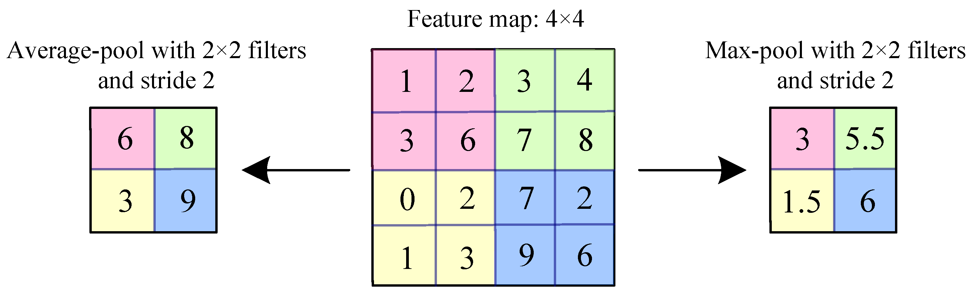

*Figure 3.2; A schematic diagram of a pooling operation.*

## Deep Learning image classification technology

In the subject of computer vision, some of the difficulties that are currently being faced include picture classification, target recognition, and image segmentation. Labeling photographs within the confines of a predetermined classification set is the primary activity involved in image classification. Deep learning might potentially aid medical practitioners in promptly recognizing abnormalities in endoscopic pictures, hence reducing the amount of time and resources necessary for such assessments. This would be accomplished by integrating deep learning with medical endoscopic images. The use of deep learning in the field of image processing has led to considerable advancements in this area of study. In this part, we will look at the properties of some of the more traditional deep learning models. This will include the VGG network, which has shown that the depth of a network has a direct effect on its performance; the GoogLeNet network, which incorporates the Inception module to reduce parameters; the ResNet network, which uses shortcuts to address the issue of model degradation; and the MobileNet network, which prioritizes lightweight models. All of these networks have been developed by Google.

### VGG Network

The Visual Geometry Group at Newton University launched the VGG network in 2014, and it quickly rose to prominence within the computer vision field because to its outstanding performance in the ImageNet competition in the same year. Conv3-64 refers to a volume layer that has 64 3x3 volume cores, and it was one of the six unique configurations that were suggested in the original VGG article. These configurations were distinguishable from one another based on the number of volume cores included inside the volume layer. Even though the total number of parameters employed by the different configurations was not particularly high, the bulk of the parameters were put to use by the last three levels that were completely coupled. All of the VGG networks had a core design that was relatively comparable to one another, consisting of 3x3 volume nodes and 2x2 maximum pooling. Also, performance increases were shown as the network depth grew. Nonetheless, in spite of the fact that the initial half of the network only had a limited number of parameters, the bulk of the computational resources were used while the model was being trained on it.

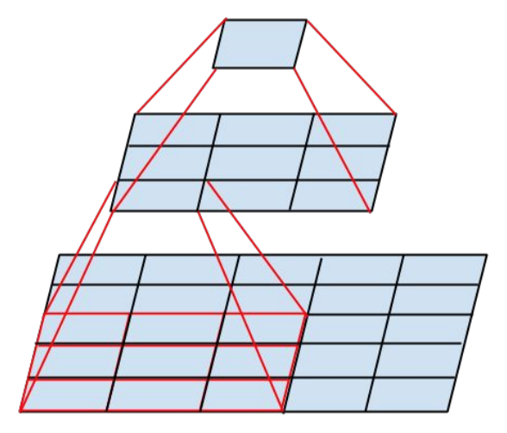

*Figure 3.3; Two 3 ×3 volume nuclear stacks*

The VGG network is well-known for its ground-breaking stacking of several small-scale convolutional kernels of size 3 x 3, which substitutes bigger kernels (5 x 5, 7 x 7, 11 x 11). For example, stacking two 3 x 3 kernels may be used to replace one 7 x 7 kernel, while using three 3 x 3 kernels can be used to replace one 7 x 7 kernel. There is no change to the receptive field, however there has been a decrease in the number of factors. If we assume that the total number of channels in and out is C, then the number of parameters necessary for the 7 7 kernel is 49C2. On the other hand, the number of parameters necessary for stacking three 3 3 kernels is 3 3 C 3 + 3 C C 3, which is equivalent to 27/49 of the parameters necessary for the 7 x 7 kernels.

The non-linear expressiveness of the model is improved as a result of this decrease in the number of parameters. The following is an explanation of the reasoning for using two sets of three-by-three kernels rather than one set of five-by-five kernels. After that, the 3 x 3 kernel calculates the filter volume, and a completely connected 3 x 3 layer computes the output. First, the 5 x 5 kernel operates as a smaller fully connected network, sliding across a 5 x 5 region; next, the 3 x 3 kernel calculates the filter volume. This completely linked layer may be thought of as a 3 x 3 convolutional layer since it contains all of the previous layers. As a consequence of this, one kernel measuring 5 x 5 may be replaced by two kernels measuring 3 x 3, as shown in Figure 2-3. On the other hand, the VGG network consists of three layers that are all completely linked, which results in a greater number of parameters that need to be learned and a more gradual learning process.

### GoogLeNet Network

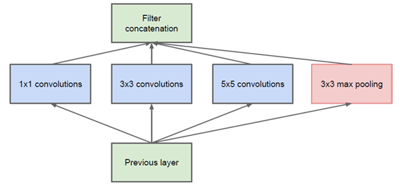The Google team came out on top in the ImageNet classification competition with their GoogLeNet model, which was built in 2014. Previous network models, such as AlexNet and VGG, which depended on increasing the number of layers to obtain increased performance, have been superseded by this model, which constitutes a shift from those earlier models. The straightforward expansion of the network's depth, on the other hand, resulted in problems such as gradient dispersion, gradient overfitting, and computational complexity.

1. *Original Inception network structure*



1. *Open Inception network structure*

An innovative strategy for improving the performance of deep learning models is represented by Google's Inception architecture, which serves as a key component of the company's neural network. It makes advantage of multi-scale properties to make the most efficient use of the available computational resources. In addition, Google's neural network has a 1-1 convolutional core that helps with mapping and dimension reduction. It also has two auxiliary classifiers that provide assistance with the classification process. In order to make the model more straightforward, GoogleNet swaps out the entirely linked layer with an average pooling layer.

The pooling layer that is included in GoogleNet's Inception design (depicted in Figure 22-4(a)) is what sets it apart from other networks like GoogleNet. Figure 22-4(b) shows an optimized version of the Inception structure, which has a bigger 1 1 convolutional core than the original version. This decreases the number of parameters and the depth of the feature map, which in turn decreases the amount of computation that has to be done. The expressive capacity of the network may also be improved by using nonlinear activation functions after the core of the 1-1 convolutional layer.

As a solution to the issue of disappearing gradients, Google's GoogLeNet makes use of two extra SoftMax layers. These layers enable the propagation of gradients while the network is being trained. These extra classifiers are only activated while the model is being trained; they are turned off when the model is being used for regular predictions. Since auxiliary branches may regularly exceed the accuracy of the main network as training nears completion, this technique offers a more streamlined training process and increased convergence, resulting in a higher training level. Moreover, this strategy enables enhanced convergence.

### ResNet Network

2015 was the year when Microsoft Labs unveiled the ResNet[48] architecture, and in the same year it participated in the ImageNet competition, it achieved remarkable results. It was the first to win the picture division, as well as the category assignments, and the COCO data target testing. The achievement of ResNet is a watershed point in the history of Convolutional Neural Network (CNN) image processing since it addressed the basic challenge of deep CNN model training. This was a significant step forward in the field.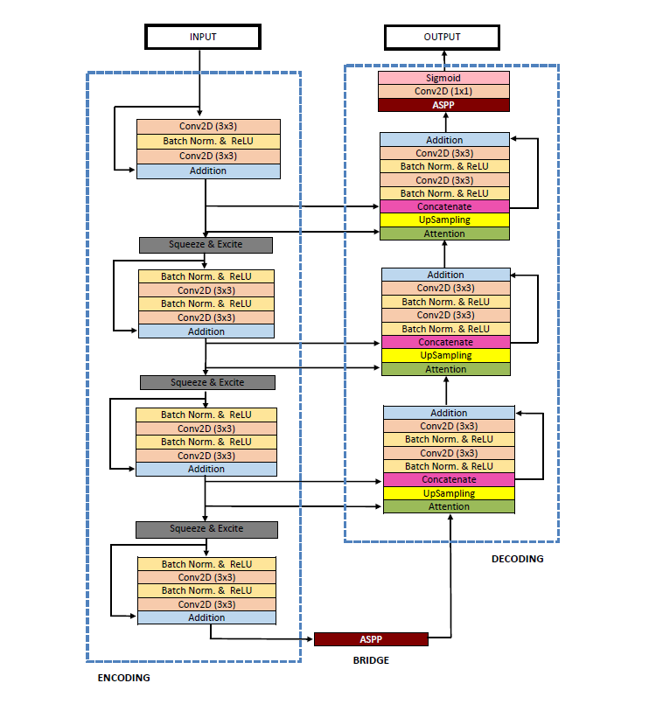

Figure 3.4;

As compared to its predecessors, such as the VGG network, which had just 19 layers, and GoogLeNet, which had 22 layers, ResNet's extraordinary number of 152 layers represented a significant shift in the depth of the network architecture. The number of layers a network model has is directly correlated to the complexity of the feature models it can acquire; hence, the depth of the network model is an essential factor in determining how well it will function. Unfortunately, the precision of the network hits a saturation threshold as the depth of the model rises, which leads to issues such as loss of gradients and even explosion.

The authors of ResNet presented many ways of residual learning in an effort to solve this problem. The concept of residual learning proposes that after the learned properties of a multi-layer volume have been recorded as H(x), one should proceed to learn the residual difference F(x), which is defined as H(x) minus x. Learning the difference between the two is easier than directly learning the original characteristics, which makes learning the residual difference possible. This opens the door to improved characteristics. The multi-layer volume structure is only able to accomplish constant-level mapping when the residual difference is equal to zero; nevertheless, this does not result in a reduction in the characteristics. In actuality, the residual difference is not zero, which results in the acquisition of new characteristics depending on the input characteristics of the multi-layer volume structure, which ultimately leads to an improvement in performance.

Figures 2 through 5 illustrate the fundamental structure of residual learning, which may be thought of as being analogous to a "short-connection" in a circuit. A shortcut link lies at the heart of the concept of residual learning.

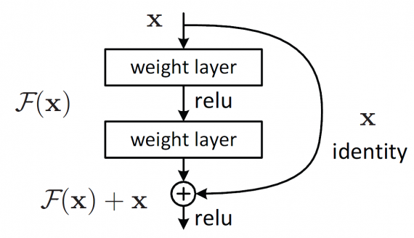

*Figure 3.5; Schematic diagram of the residual unit [45]*

The architecture of ResNet includes two different designs that may be used to implement the residual module. The first architecture, which can be seen shown in Figure 2-6, makes use of two convolutional kernels measuring 3 by 3, and stacks them. The second design consists of a first layer of 64 1 1 convolutional kernels, which reduce the 256-dimensional feature to 64 dimensions, followed by a 3 3 convolutional layer, and finally a 256 dimensional 1 1 convolutional layer to restore its dimension. This reduces the feature from 256 dimensions to 64 dimensions. When the second design is used, it results in a decrease in the total number of parameters, which in turn makes it easier to do a lighter quantification of the model.

The first design may be used for standard ResNets that have 34 layers or less, whereas the second design for the residual unit is beneficial in lowering calculation time for deeper ResNets such as ResNet50, ResNet101, and ResNet152. It is essential to take notice that during the process of final feature fusion, the residual unit is not stacked at the channel level; rather, it is added directly to the feature matrix of the same form. This is one of the most crucial aspects of the procedure.

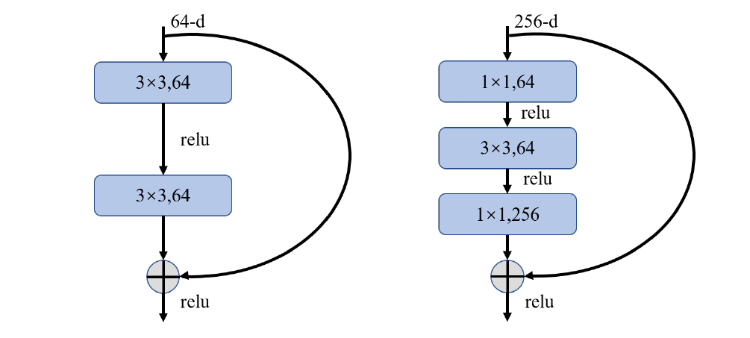

*Figure 3.6; Realization of two residual structures [48]*

### MobileNet Network

The number of cucumbers in the network that was constructed by utilizing the typical rolling neural network is fairly high, as is the need for a high level of memory and arithmetic. Because of these variables, relocating devices or embedded devices might be challenging. Work. In response to this problem, MobileNet was designed and built. The MobileNet network model was developed by the Google team in 2017, with the intention of focusing on lightweight rolling neural networks in mobile terminals and embedded devices. As compared to more standard rolling neural networks, the accuracy is noticeably lower.

If, for example, there is, the calculation for model participation could be able to be much reduced. While it has a 0.9% lower accuracy than the VGG16 model, the model parameter is just one-third of what it should be for the 32nd iteration. In conventional volume calculations, the number of channels for volume nuclei is roughly equal to the number of channels for feature maps (feature map), and the number of channels for output feature map is roughly equal to the number of volume nuclei. Additionally, the number of channels for output feature map is approximately equal to the number of volume nuclei. The number of channels for volume calculation is one, and the number of channels for feature map input is equal to the volume of volume core in MobileNetV1[49]. It is recommended to use depth to separate the volume (Depth wise Separable Conv), the number of channels for volume calculation is one, and the number of channels for volume core input is equal to the volume. At the same time, in proportion to the amount of output produced by the feature map.

This lightweight model is able to function on mobile devices while retaining an accuracy level equivalent to that of other large networks since the number of accessible channels may help achieve the aim of reducing the number of network computations. MobileNet simultaneously created two super-parameters, the width factor (Width Multiplier) and the resolution factor (Resolution Multiplier), in order to further regulate the size of the network. These super-parameters are referred to as the width factor and the resolution factor, respectively.

The deep separable volume technique may be broken down into two main steps: the deep volume step (Figure 2-7), and the point-by-point volume phase (Figure 2-8). The number of output channels is set to 2, the filling parameter is determined to be 1, and the output dimension of the standard volume is 224 TAG. The number of references is 3 x 3 x 3 x 2=54, and the estimated amount is 2 x224 x 3 x 3 x 3x 3 x 3. During the deep volume process (Figure 2-7), the inputting dimension was 224 by 224 by 3, the volume core parameter was 3 by 3 by 1TepG1> Feature 3, each channel created 3 by 3 volumes, and the output feature dimension was 224 by 224 by 3.

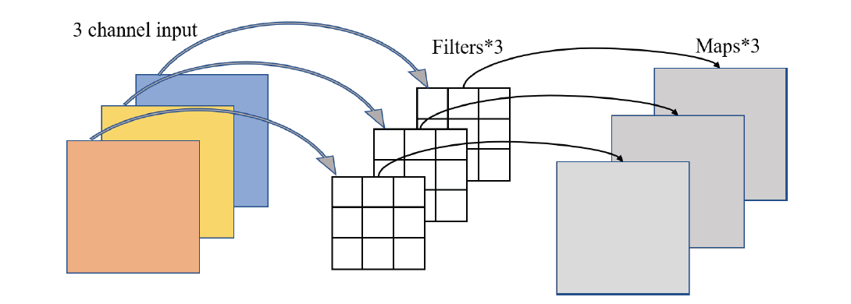The point-by-point volume should then be entered, along with the volume core parameter 1 1 3 2, the common volume for the Features should be set to 2 1 1, and the output dimension should be 224 x 224>T. The number of references that have deep separable volumes is 33, which may be calculated as 3 x 224x 224 x3 /2709504=33/54=0.61 using the following formula: 3 x3 x 3+3 x2. This demonstrates that there has been a reduction in the number of parameters and computations to a volume that is 0.61 times that of the conventional volume.

*Figure 3.7; Schematic diagram of depth volume [49]*

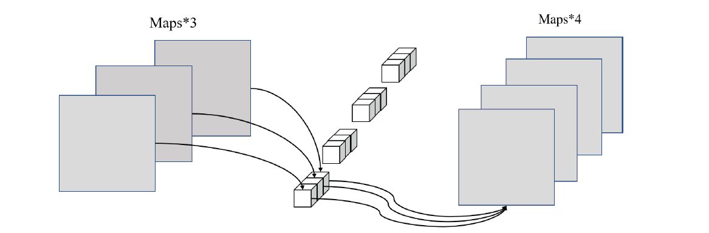

*Figure 3.8;*

The Google team unveiled its MobileNetV2[50] network in the year 2018. It has been observed that the accuracy of this network has increased in comparison to that of its predecessor, the MobileNetV1, while simultaneously having a more condensed model size. The addition of Linear Bottlenecks and Inverted Residual Blocks is one of the most significant breakthroughs made by MobileNetV2[50] in contrast to the earlier version. Enhancing the model's characterization may be accomplished by removing the non-linear activation layer from the small dimensional output layer in the Linear Bottlenecks. The Inverted Residual Blocks are a variation from the conventional method of constructing residual blocks. Instead of expanding the medium dimension first, they compress it, which then yields a feature map after the medium dimension has been expanded. Because of the vast volume of the 3x3 layer in the center, which would increase the number of multipliers if the number of channels were to stay high, it is vital to make use of precipitation and sublimation in the Residual Blocks. This is because of the large volume of the layer. It is necessary to cut down on the number of channels in order to counteract this growth.

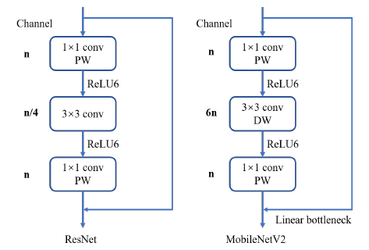

*Figure 3.9; Comparison of microstructures between ResNet and MobileNetV2*

In 2019, the Google team broke new ground in the field of deep learning when they unveiled MobileNetV3[51]. The employment of AutoML, which seeks to discover the most suitable neural network structure for a certain undertaking, is the fundamental contribution that MobileNetV3[51] makes to the field of artificial intelligence. In order to do this, MnasNet is first used to discover rough network architectures, and then rigorous machine learning is used to choose the best structure from among a set of discrete choices. In addition, the structure is fine-tuned with the help of NetAdapt[52], which demonstrates the supplemental function of NetAdapt[52] in changing the channel structure, even for networks with a lower margin. In addition, MobileNetV3 adds a rather innovative activation function known as swish(x) Type 2-2TAG1>. This activation function has the potential to considerably improve the accuracy of the network, but at the expense of an additional amount of computation.

swish(𝑥) = 𝑥 ⋅ 𝑠𝑖𝑔𝑚𝑜𝑖𝑑(𝛽𝑥) (2-2)

An enhancement is presented by the author in the form of a replacement and approximation of the classic sigmoid activation function that makes use of ReLU6(x+3)/6. This adjustment ultimately results in a large increase in speed, as can be seen in Type 2-3. By using the ReLU6 activation function, it is possible to perform computations on any hardware and software platform, which helps to reduce the reliance on significant processing resources.

$h - swish(x) = x \frac{ReLU 6(x + 3)}{6}$ (2-3)

### DenseNet Network

Evaluation of DenseNet is carried out using a viewpoint that is characteristic-based, as detailed in reference [53]. It not only replicates the characteristics, but it also contains bypass connections, which dramatically decreases the total number of network parameters and the possibility of gradient disappearing. ResNet, on the other hand, is credited with pioneering the horizontal design, which allowed deep learning neural networks to reach greater depths and, as a result, achieve better model accuracy. This information is described in reference [48]. The introduction of shortcuts, which link the front and back layers and make it easier for the backpropagation of gradients while the network is being trained is the primary novelty that it has.

It should be pointed out that the concept that underpins the DenseNet network is comparable to that which underpins the ResNet network. Both networks include shortcuts between the front and back layers; however, the intensive connections that are established between the first and subsequent layers are a key difference. The diagram in the figure section shows that DenseNet's overarching structure is made up of DenseBlocks and Transitions. This can be seen in the diagram.

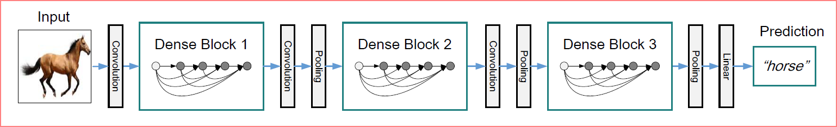

*Figure 3.10; DenseNet Basic Structure Chart*

When an input picture X0 has been processed by a neural network consisting of L layers, the non-linear fluctuations that occur at each layer I are stored as the variable Hi(). These changes may be modeled by a number of different functions, and the sum of the results of all of these operations is denoted by the Xi variable. The output Xi of the current layer I is used as the input for the next layer (i+1) in a neural network that follows the standard feedforward architecture. Thus, Xi may be represented by the following mathematical expressions:

𝑋𝑖 = 𝐻𝑖(𝑋𝑖−1) (2-4)

ResNet was the first network protocol to implement a jumping connection and inherited identification features from the layer below it.

𝑋𝑖 = 𝐻𝑖(𝑋𝑖−1) + 𝑋𝑖−1  (2-5)

One of the most significant advantages of ResNet is that the gradient may return to the level it was at over a very short connection. In Dense-Block, the input of the I layer is linked to the output of all layers that came before it, and this output is recorded as the following:

𝑋𝑖 = 𝐻𝑖 ([𝑋0, 𝑋1, ..., 𝑋𝑖−1]) (2-6)

Among these, [] is the symbol for the splicing operation, also known as concatenation. This operation combines all of the output feature maps on the channel dimension, which ranges from X0 to Xi1. The BN+ReLU+33Conv structure is used by the nonlinear combination function H() that is part of DenseBlock. At the completion of each layer of volume in the DenseBlock, a k feature map is exported. To put it another way, each layer contains k volume of space. The growth rate, also known as the growth rate in DenseNet, is denoted by the letter k, and it serves as a super parameter for the model.

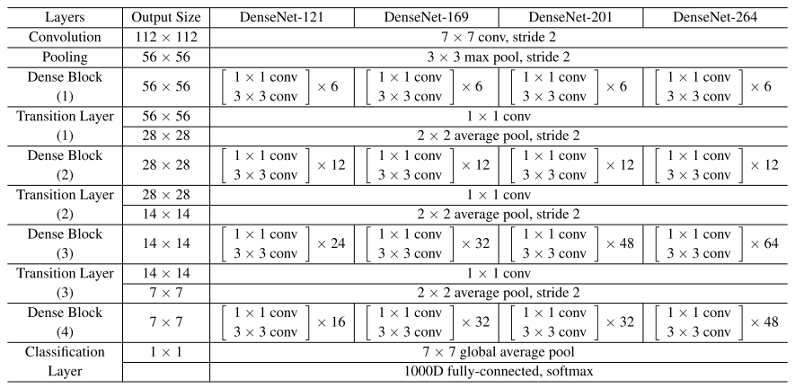Table 3-1 DenseNet121 Model Structure

Each architecture in the DenseNet architecture is made up of four DenseBlocks, and these DenseBlocks have a varied number of layers. For example, the DenseNet-121 has a layer configuration of [6, 12, 24, 50] in each of the four dense blocks, but the DenseNet-169 has layers configured in the following way: [6, 12, 32, 32]. After the first 7x7 stride-2 Conv Layer in the DenseNet design is a 3x3 stride-2 MaxPooling layer. This is the beginning of the architecture. The last dense block is preceded by a Classification Layer, which is responsible for carrying out the classification procedure by using the feature maps obtained from each of the network's layers in turn.

Moreover, the bottleneck layers in each design represent the convolution processes. This indicates that the 1x1 convolution operation decreases the number of channels in the input, but the 3x3 convolution operation conducts the convolution operation not on the original input but rather on the modified version of the input that has a decreased number of channels.

## Summary

This chapter provides a detailed analysis of the theoretical underpinnings of deep learning's use of convolutional neural networks. It investigates and analyzes five traditional models of convolutional neural networks, including the VGG network, the GoogLeNet network, the ResNet network, the MobileNet network, and the DenseNet network. This chapter gives a comprehensive overview of the possibilities for applying deep learning to the subject of automated resistive meat identification in capsule endoscopy pictures, as well as highlighting the significant advancements that have been achieved in image processing as a result of deep learning.

# Chapter 4

## Proposed Network Name: NanoNet

## NETWORK ARCHITECTURE

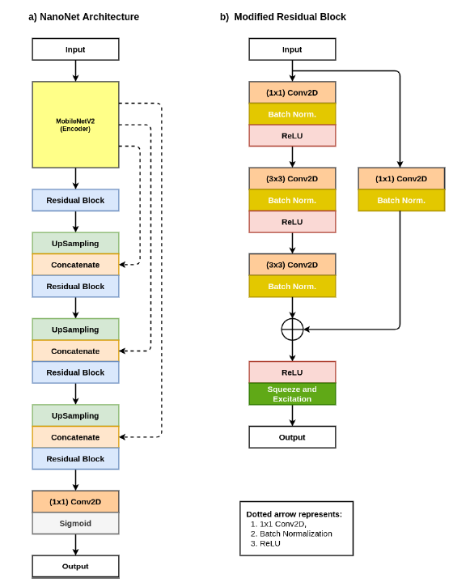Figure 4.1 is a representation of the encoder-decoder approach that is employed by the design of NanoNet. As can be seen in Figure 1, the encoder of the network is a pre-trained model, which is then followed by three blocks of decoders. Transfer learning using previously trained models from ImageNet [34] has been shown to be the most effective technique for a variety of CNN architectures [8, 25]. It allows the model to converge much faster and attain exceptional performance when compared to the model that was not pre-trained, which is a benefit that this feature provides. As the encoder, the suggested architecture makes use of a MobileNetV2 [33] model that has been pre-trained using the ImageNet [34] dataset. The decoder is built with the help of the residual block, which is a novelty that was introduced for the first time by He and his colleagues [35]. Although the encoder is responsible for obtaining

Figure 4.1; Block diagram of (a) NanoNet architecture, and (b) Modified Residual block [80]

the necessary contextual information from the input, the decoder is in charge of producing the final output by making use of the contextual information that was obtained by the encoder.

1. MobileNetV2

The MobileNetV2 [33] architecture is mainly designed with mobile and embedded devices in mind. The design worked well on a variety of datasets while maintaining a high level of accuracy, despite having fewer parameters than other designs. The design of MobileNetV2 is based on the architecture of MobileNetV1, which makes use of depth-wise separable convolutions as the fundamental building component in its construction. The formation of a depth-wise separable convolution begins with the execution of a depth-wise convolution, followed by the completion of a point-wise convolution. In the previous chapter, we said that MobileNetV2 is comprised of two key ideas: inverted residual blocks and linear bottleneck blocks [33]. The bottleneck residual block, which is described in [35], serves as the foundation for the inverted residual block. This block is made up of three typical convolutions: 1 1, 3 3, and 1 1. A non-linearity known as a Rectified Linear Unit (ReLU) comes into play after each and every convolution layer. The number of feature channels is decreased after the first round of 1 x 1 standard convolution, but it is increased after the last round of 1 x 1 standard convolution. After that, an addition is carried out utilizing the identity mapping by adding each individual element in turn.

In the inverted residual block, there are three convolution layers: a 1 x 1 standard convolution, a 33 depth-wise convolution, and a 1 x 1 standard convolution. Every convolution has a ReLU activation function as one of its components. In this particular instance, the bottleneck residual block is replaced with its polar opposite. The number of feature channels grows during the first standard convolution but shrinks during the final standard convolution. This is because the first standard convolution creates more feature channels. It is given this name because its functions are diametrically opposed to one another. Because of the fact that it performs in the opposite manner, it is referred to as an inverted residual block. The linear bottleneck block is the same as the inverted residual block, with the exception that the linear activation comes before an element-by-element addition with the identity mapping. Other than that, the linear bottleneck block and the inverted residual block are identical.

1. Modified Residual Block

The first residual block is made up of a batch normalization, two 3 x 3 standard convolutions, and a ReLU activation function. A batch-normalization takes place immediately after the second convolution. After the execution of one more ReLU activation function, an addition is carried out on an element-by-element basis between the result of the batch normalization and the identity mapping. An identity mapping is created by doing a batch-normalization of the initial input after performing a conventional convolution. We made changes to the remaining portion of the network. After starting with a convolution of 11, the modified residual block finishes with a convolution of 3, 3, respectively.

In each of these convolutions, the number of filters is decreased by a factor of four, and then the batch normalization and the ReLU activation function are performed thereafter. A 3 x 3 convolution with bulk normalization is what is being used here. Now, with the help of the identity mapping, we are going to carry out an addition one element at a time. In conclusion, we will build a ReLU activation function, which will then be followed by a block including compression and excitation. The compression and excitation block raises the sensitivity of the map to more important features, which helps to enhance the overall quality of the feature map.

1. The NanoNet architecture

The architecture of NanoNet is shown here by a block diagram, which can be seen in figure 4.1. In the architecture of NanoNet, an encoder that has been pre-trained using MobileNetV2 is followed by a decoder. There is a modified residual block that acts as a conduit between the encoder and the decoder. This block is located between the encoder and the decoder. At the beginning stage, the encoder that has already been pre-trained receives the picture data that has been processed. The pre-trained encoder starts out with a normal convolution that consists of 32 feature channels, and then it moves on to the bottleneck layer, which uses ReLU6 as its activation function. All convolutional procedures use a kernel with dimensions of three by three as their default setting. The whole encoder network uses stride convolution to down sample the feature maps while gradually increasing the number of feature channels. This is done in order to maximize compression efficiency.

The output of the pre-trained encoder is supplied to the decoder by way of the modified residual block. The spatial dimension of the input feature maps is increased by each step of the decoder by the use of bilinear up sampling, which increases both the height and breadth of the maps. After that, the skip connections are utilized to concatenate it with the matching feature maps from the encoder that has already been trained. By transferring information that might otherwise be lost across layers, these bypass links help to improve the overall quality of feature maps. After that, the revised residual block will analyze the concatenated feature maps, which will result in an even greater generalization power for the decoder. When the feature maps have been processed by all three decoder blocks, the output of the final decoder block is then delivered to a 1 x 1 convolution that uses several classes as the feature channels. This occurs after the last decoder block has been executed. We use the sigmoid activation function if the job includes binary segmentation; otherwise, we use the SoftMax activation function

The three different NanoNet designs that we looked at are denoted by the letters A, B, and C respectively. The decoder block of each design is composed of a wide variety of feature channels. Depending on the functionality, NanoNet-A may use either 32, 64, or 128 channels. The maximum number of feature channels that may be used with NanoNet-B is either 32, 64, or 96. NanoNet-C brings the number of feature channels down to 16, 24, and 32 from their previous levels. A lightweight network is the result of reducing the number of feature channels, which in turn leads to fewer trainable parameters, which in turn decreases the complexity of the model.

Table 1; Publicly available endoscopic datasets used in our experiments

|  |  |  |
| --- | --- | --- |
| Dataset | Imaging Type | Availability |
| KvasirCapsule-SEG |  | https://www.dropbox.com/sh/hr46vieykbmvmkk/  AAAs V8ECG0wq51Fpw3rYU 5a?dl=0 |
| Kvasir-SEG | Colonoscopy | https://datasets.simula.no/kvasir-seg/ |
| 2020 Medico automatic polyp segmentation challenge | Colonoscopy | https://multimediaeval.github.io/editions/2020/tasks/  medico/ |
| Endotect Challenge Dataset | Colonoscopy | https://endotect.com/ |
| Kvasir-Instrument | Colonoscopy | https://datasets.simula.no/kvasir-instrument/ |

## Experimental Setup

In this part, we will talk about the dataset that was used, the assessment criteria, the details of the implementation, and the data augmentation strategies.

The dataset is the collection of data that was utilized in this research; it serves as the foundation for the whole inquiry. As a consequence of this, it is absolutely necessary to offer a detailed description of the dataset that was utilized, including information on its size, its origin, and any preparation steps that were carried out. In addition, it is necessary to provide a justification for the use of this specific dataset as opposed to other possibilities and to emphasize both its strengths and drawbacks.

On the other side, evaluation metrics provide a quantitative approach for assessing the effectiveness of the model. As a result, it is very necessary to provide a description of the measurements that were used in this research, as well as their relevance to the activity at hand and any restrictions that may have been present. The programming language, software, and hardware that were used are all examples of implementation details. These are the technical specifications of the technique that was used for the research. In addition to that, the hyperparameters, initialization processes, and optimization techniques that were used when training the model need to be documented in depth.

The term "data augmentation methodologies" refers to the many different methods that may be used to expand the diversity of the training dataset by creating new samples based on the ones that already exist. Image inversion, cropping, rotation, and brightness correction are only some of the techniques that fall under this category; nevertheless, the list is not exhaustive. It is vital to detail the specific approaches that were used and provide a justification for selecting them rather than other options.

In general, it is crucial to have clear information about the dataset, evaluation criteria, implementation specifications, and data augmentation processes that were employed in a study. This is necessary for assuring the research can be reproduced and is transparent.

### Datasets

We collected the polyp class from the tagged pictures folder of the Kvasir-Capsule dataset [37] and annotated it with the assistance of a gastroenterologist in order to tackle the challenge of segmenting polyps from video capsule endoscopy images. The Kvasir-Capsule is a dataset that can be accessed freely and contains labeled oddities and discoveries organized into thirteen different categories. Just 55 polyp frames out of a total of 44,228 medically proven ideo capsule frames are included in the Kvasir-Capsule. The Kvasir-Capsule polyp class has been annotated, and ground truth masks have been constructed in compliance with this annotation. Examples of KvasirCapsule-SEG colonies and their corresponding covers are shown in Figure 2. In addition, we provide information on the bounding box for detection and localization tasks associated with endoscopic video capsules.

At this URL, the Kvasir-Capsule may be downloaded on your computer. Downloads of version 1. 1 and KvasirCapsule-SEG are available from this page. The information in Table I applies to the publicly available imaging dataset that was used in the studies that we conducted. Table I has a ground truth column that corresponds to each dataset that is given there. The table provides the web address (URL) that corresponds to each dataset. The "Medico automated polyp segmentation challenge" and the "Endotect challenge" use the Kvasir-SEG as the standard training settings. The organizers of the challenge have given the participants with 160 previously unseen photographs for the "Medico automated polyp segmentation challenge" and 200 previously unseen images for the "Endotect challenge" so that they may assess the participants' methods. Experiments were carried out using the official division that was made available to us by the organizers of the Kvasir-instrument dataset. [10–13] elucidate these datasets as well as the findings of the baseline study.

### Evaluation metrics

For the purpose of this investigation, the performance of our suggested model was evaluated using standard metrics from the field of computer vision. For our measures, we made use of the Dice Coefficient (DSC), the mean Intersection over Union (mIoU), Precision, Recall, Specificity, and Accuracy, as well as Frames-per-second (FPS).

The Dice Coefficient is a common metric for evaluating different segmentation methods. It is a measure of the overlap that exists between two binary masks. The DSC metric may have a value between 0 and 1, with 1 indicating an exact correlation between the predicted and ground truth masks. mIoU is a metric that is used to evaluate segmentation algorithms. This metric evaluates the average intersection over union of predicted and ground truth masks across all classes. When working with imbalanced datasets in which certain classes may be underrepresented, the mIoU measure is very helpful because of its ability to identify areas of underrepresentation.

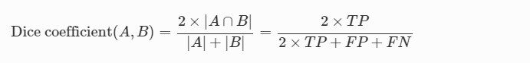

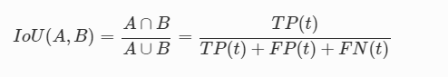Intersection over Union (IoU): Another common metric for assessing the effectiveness of a segmentation strategy is the intersection over union (IoU). The following equation demonstrates how the IoU calculates the degree of similarity between a predicted value (A) and the ground truth value (B) that corresponds to it.

In Equation 2, the variable t stands for the threshold. A precision value is computed for each threshold value t by comparing the predicted item to all of the ground truth items. This is done by using the equation and parameters that were just discussed. While doing frame-wise image classification tasks, additional criteria such as recall, specificity, precision, and accuracy are applied. A comprehensive description of these variables may be found in the paper that describes the Kvasir dataset.

In binary classification tasks, standard measurements called precision, recall, and specificity are used to offer information about a model's capacity to reliably categorize positive and negative events. These measures are called precision, recall, and specificity. Precision evaluates the percentage of genuine positives compared to real positives, while recall measures the proportion of actual positives related to genuine positives. Both precision and recall are important for diagnostic accuracy. On the other hand, specificity determines the fraction of genuine negative occurrences that are actual by doing a calculation. Accuracy is a key measure that quantifies the percentage of properly classified instances across all occurrences and is used in classification tasks. Although though accuracy is a helpful statistic, it is possible that it should not be used for datasets that have uneven class distributions and skewed class balance.

The FPS measure was developed so that we could determine how well our suggested model would perform in terms of computing. The number of frames that can be processed in one second is denoted by the FPS meter. This metric is of utmost significance for real-time applications since these kinds of programs need very fast processing rates. We want to give a detailed assessment of the performance of our proposed model across several tasks using these standard computer vision measures. These tasks include segmentation and classification.

### Implementation details

Keras and TensorFlow were used as backend tools during the development of the NanoNet model. The tests were carried out using a Lenovo ThinkPad T470s that had a Central Processing Unit (CPU) clocked at 2.60 GHz belonging to the Intel Core i5-7300U family and a Chipset Memory Intel SoC (System on Chip) architecture. You may get the source code that was used to implement the NanoNet model at https://github.com/lesotlhok/TheaNanoNet. In order to make the most of the available computational resources and taking into consideration the fact that the NanoNet model only has a limited number of trainable parameters, we decided on a batch size of 16. In order to make the process of training more effective, we reduced the size of the input pictures in the dataset to 256 by 256 pixels. This not only improves GPU usage but also shortens the overall amount of time spent training.

We used the nadam optimizer to train the model, and the dice coefficient served as the loss function. Dice coefficients are commonly used in segmentation tasks because of their ability to quantify the degree to which predicted masks and ground truth masks are similar to one another. We have decided to go with the more moderate setting of 1e-4 for the optimizer's learning rate. This is done to guarantee that the parameters of the model are adjusted in a gradual and careful manner, which ultimately results in improved convergence and overall effectiveness.

To make the training process even more effective, we have reduced the learning rate by 0.1 percentage points if the validation loss is unchanged for ten iterations in a row (epochs). This method assists in avoiding overtraining and helps to keep the training process stable. In addition, a system that stops the fitting process early was put into place to avoid overfitting. This tactic keeps an eye on the validation loss and aborts the training process after a certain number of iterations if the loss has not decreased. We anticipate that if we give careful consideration to the selection of hyperparameters and training techniques, we will be able to improve both the efficiency of the training process and the functionality of the NanoNet model.

TABLE2: Evaluation of the proposed network performance and contemporary SOTA approaches on the KvasirCapsule-SEG

|  |  |  |  |  |  |  |  |  |
| --- | --- | --- | --- | --- | --- | --- | --- | --- |
| **Methods** | **Parameter** | **DSC** | **mIoU** | **Recall** | **Precision** | **F2** | **Accuracy** | **FPS** |
| ResUNet (GRSL’18) [38] | 8,227,393 | 0.9532 | 0.9137 | 0.9785 | 0.9325 | 0.9677 | 0.9386 | 17.96 |
| ResUNet++ (ISM’19) [24] | 4,070,385 | 0.9499 | 0.9087 | 0.9762 | 0.9296 | 0.9648 | 0.9334 | 15.39 |
| NanoNet-A | 235,425 | 0.9493 | 0.9059 | 0.9693 | 0.9325 | 0.9609 | 0.9351 | 28.35 |
| NanoNet-B | 132,049 | 0.9474 | 0.9028 | 0.9682 | 0.9308 | 0.9593 | 0.9324 | 27.39 |
| NanoNet-C | 36,561 | 0.9465 | 0.9021 | 0.9754 | 0.9238 | 0.9629 | 0.9297 | 29.48 |

TABLE 3 Evaluation of the proposed network performance and contemporary SOTA approaches on the Kvasir-SEG [78]

|  |  |  |  |  |  |  |  |  |
| --- | --- | --- | --- | --- | --- | --- | --- | --- |
| **Methods** | **Parameter** | **DSC** | **mIoU** | **Recall** | **Precision** | **F2** | **Accuracy** | **FPS** |
| ResUNet (GRSL’18) [38] | 8,227,393 | 0.7203 | 0.6106 | 0.7602 | 0.7624 | 0.7327 | 0.9251 | 17.72 |
| ResUNet++ (ISM’19) [24] | 4,070,385 | 0.7310 | 0.6363 | 0.7925 | 0.7932 | 0.7478 | 0.9223 | 19.79 |
| NanoNet-A | 235,425 | 0.8227 | 0.7282 | 0.8588 | 0.8367 | 0.8354 | 0.9456 | 26.13 |
| NanoNet-B | 132,049 | 0.7860 | 0.6799 | 0.8392 | 0.8004 | 0.8067 | 0.9365 | 29.73 |
| NanoNet-C | 36,561 | 0.7494 | 0.6360 | 0.8081 | 0.7738 | 0.7719 | 0.9290 | 32.17 |

TABLE 4: Evaluation of the proposed network performance and contemporary SOTA approaches on the Medico 2020 dataset [79]

|  |  |  |  |  |  |  |  |  |
| --- | --- | --- | --- | --- | --- | --- | --- | --- |
| **Methods** | **Parameter** | **DSC** | **mIoU** | **Recall** | **Precision** | **F2** | **Accuracy** | **FPS** |
| ResUNet (GRSL’18) [38] | 8,227,393 | 0.6846 | 0.5599 | 0.7235 | 0.7236 | 0.6961 | 0.9231 | 18.54 |
| ResUNet++ (ISM’19) [24] | 4,070,385 | 0.6925 | 0.5849 | 0.8249 | 0.6840 | 0.7434 | 0.8995 | 19.47 |
| NanoNet-A | 235,425 | 0.7364 | 0.6319 | 0.8566 | 0.7310 | 0.7804 | 0.9166 | 28.07 |
| NanoNet-B | 132,049 | 0.7378 | 0.6247 | 0.8283 | 0.7373 | 0.7685 | 0.9223 | 29.04 |
| NanoNet-C | 36,651 | 0.7070 | 0.5866 | 0.8095 | 0.7089 | 0.7432 | 0.9148 | 32.66 |

TABLE 5: Evaluation of the proposed network performance and contemporary SOTA approaches on the Endotect 2020 dataset [80]

|  |  |  |  |  |  |  |  |  |
| --- | --- | --- | --- | --- | --- | --- | --- | --- |
| **Methods** | **Parameter** | **DSC** | **mIoU** | **Recall** | **Precision** | **F2** | **Accuracy** | **FPS** |
| ResUNet (GRSL’18) [38] | 8,227,393 | 0.6640 | 0.5408 | 0.7510 | 0.6841 | 0.6943 | 0.9075 | 26.55 |
| ResUNet++ (ISM’19) [24] | 4,070,385 | 0.6940 | 0.5838 | 0.8797 | 0.6591 | 0.7597 | 0.8841 | 18.58 |
| NanoNet-A | 235,425 | 0.7508 | 0.6466 | 0.8238 | 0.7744 | 0.7773 | 0.9255 | 27.19 |
| NanoNet-B | 132,049 | 0.7362 | 0.6238 | 0.8109 | 0.7532 | 0.7646 | 0.9252 | 29.91 |
| NanoNet-C | 36,651 | 0.7001 | 0.5792 | 0.8000 | 0.7159 | 0.7380 | 0.9091 | 32.98 |

### Data Augmentation

To make our deep learning model more effective and applicable in a wider range of situations, we supplemented the training data with additional information using a number of different methods. These tactics try to expand the diversity of the dataset by producing new versions of already existing pictures. This will assist the model in learning more robust and discriminative features that can be used to data that was not known to it before.

This work used a variety of data improvement strategies, including grid distortion, random cropping and rotation, horizontal and vertical flipping, and horizontal and vertical flipping. Offline processing was used for these approaches, which means that the augmented pictures were created and stored on disk before the training phase was carried out. This approach reduced the amount of computational power that was wasted during the training phase and sped up the process of iterating and testing with varied degrees of augmentation.

Data augmentation is a potentially useful method for improving the performance of deep learning models; nevertheless, it must be used with extreme care in order to realize its full potential. Techniques to augmentation that are too aggressive or that create exaggerated changes into the data may actually cause the model's performance to deteriorate because they cause the model to overfit to the training data or to acquire features that are irrelevant or misleading.

Just the training set was expanded, and the model's efficacy was judged based on how well it performed on the original validation and testing data sets. This was done so that the model would not be overfit to the data used for training. These sets were not upgraded; rather, they were scaled to the same 256 × 256 resolution as the training photos. This was done so that the results would be consistent across all sets. After receiving a solid assessment of the model's real performance on data that had not been seen before, we were able to arrive at informed judgments on the level of success achieved by our augmentation strategy.

## Pre-trial Model developed

Using a convolutional neural network, I will describe a foundational model for label-based picture classification (CNN). The major purpose of this experiment is to construct a model that is capable of accurately identifying photos based on the annotations included within the dataset. This particular kind of picture categorization is necessary for a wide variety of applications, including medical imaging, object identification, and autonomous vehicle navigation systems.

Acceleration of the training process is achieved by the use of the TensorFlow library and GPU. The training process is sped up as a result of this combination, and the amount of time needed for model construction is cut down. In addition to this, it gives researchers the ability to rapidly experiment with a wide variety of models and hyperparameters.

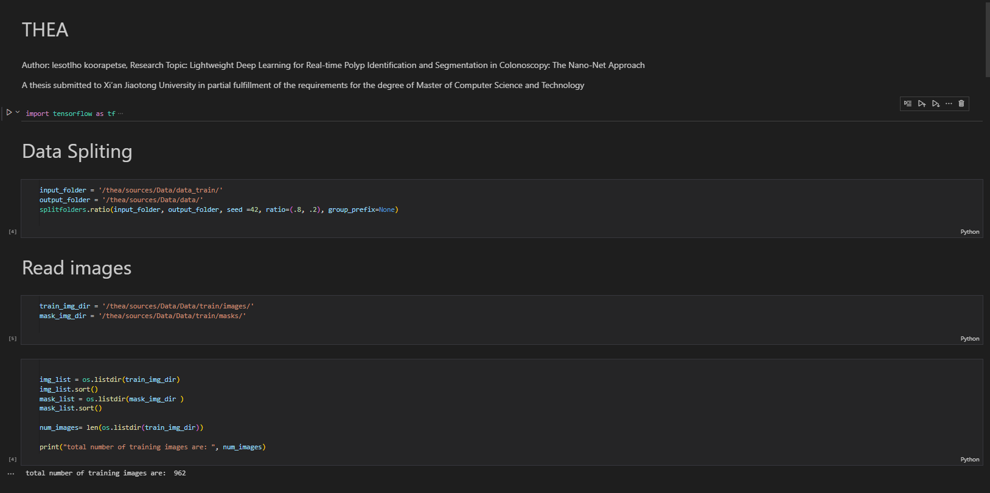The initial step in developing the model is to create two distinct subsets from the dataset: the training set and the test set. This is done in order to determine whether or not the model is effective when applied to anonymous data. Upon the completion of this task, the CNN model, together with its optimizer, loss, and metrics, is formed. The convolutional neural network (CNN) is a specialized kind of neural network that was developed specifically for the task of image processing. It is made up of a number of layers of convolutional filters, each of which extracts important aspects of the picture.

It is possible to avoid overfitting by using a method called early stopping. When the performance of the model on the validation set reaches a plateau and does not increase further, this method stops the training process. Also, in order to prevent either overfitting or underfitting, both the training accuracy and the validation loss are evaluated. In machine learning, overfitting is a common problem that occurs when a model is extremely complicated and performs well on the training data but poorly on fresh data. This occurs when the model is trying to learn too much.

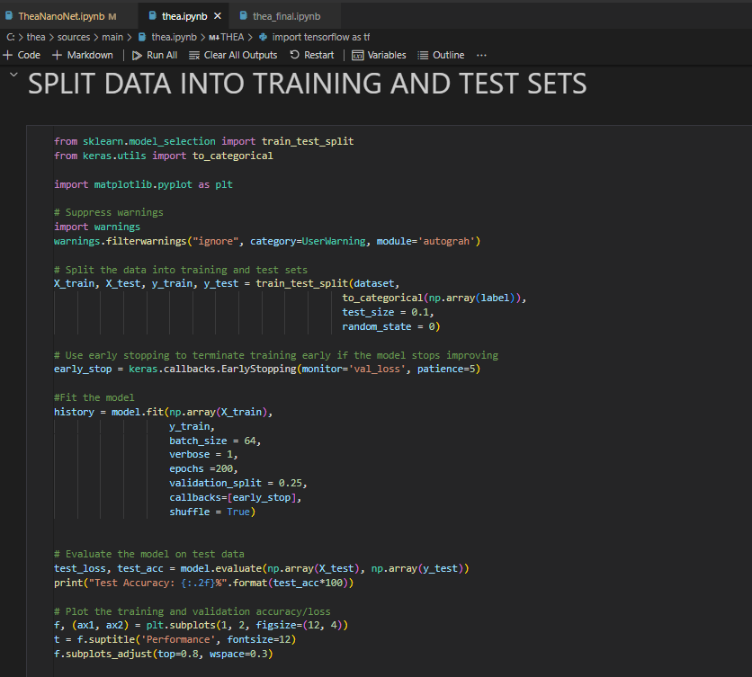

When it comes to correctly recognizing different kinds of data, the final model has a test accuracy of 53%. Despite the fact that this is a respectable output, there is still a significant amount of room for progress, since an accuracy of at least 80% is necessary for the vast majority of applications. A restricted or imbalanced dataset, overfitting, inappropriate optimization procedures, or hyperparameter changing are some of the issues that may have an impact on the performance of the model.

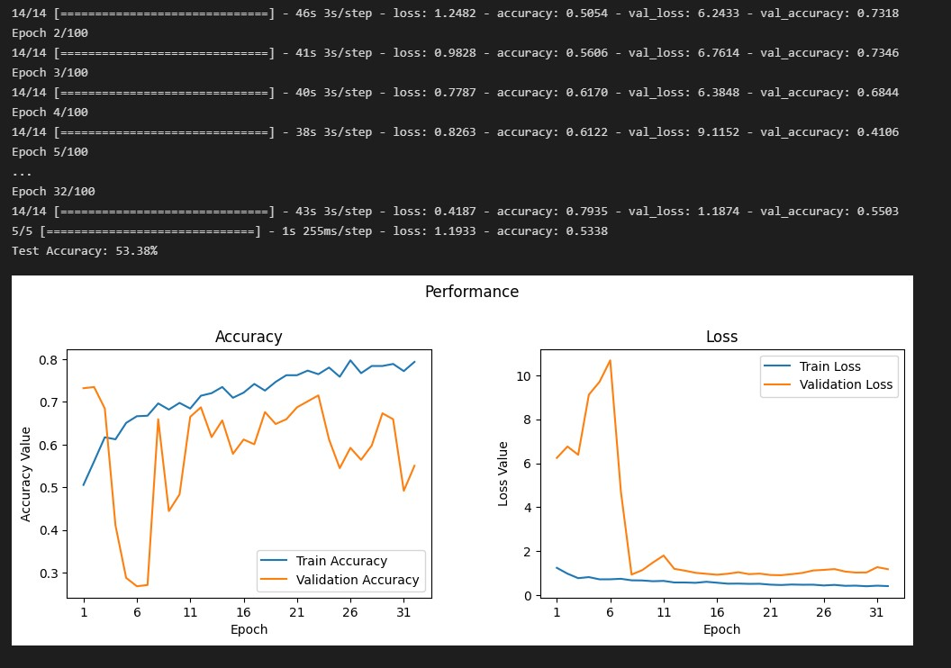

Researchers have a variety of avenues to pursue in order to find solutions to these problems. One strategy involves gathering extra data in order to increase the size of the dataset. Experimenting with different architectures and hyperparameters in order to identify which combination produces the best results for the dataset that is presented is another choice that may be made. By the use of data augmentation, one may not only expand the scope of the data set but also avoid overfitting. This comprises generating new data by subjecting the old data to a variety of transformations, such as rotations or scaling, in order to accomplish the desired result.

Overfitting may also be avoided by using regularization strategies, such as L1 and L2 regularization, among other strategies. These methods add a penalty component to the loss function, which motivates the model to learn reduced data representations and increases its likelihood of success. In addition, researchers have the ability to try out a variety of different optimizers and starting strategies in order to improve the performance of the model.

It is also important to keep in mind that the model was only trained on a small amount of data, and that it may need extra fine-tuning as well as data in order to perform efficiently on data that it has not before seen. As a result, ongoing study and experimentation are necessary in order to improve the usefulness of the model and make it more applicable. This work is a baby step toward the larger goal of developing picture classification models that are more accurate and useful for a wide range of applications.

### Finetuning and Performance Improvement

It has been established that acquiring more data has a considerable effect on the performance of machine learning models. This influence has been shown to be significant. In the current case, the inclusion of more data resulted in a noticeable 14% boost in performance, as seen by the model's accuracy improving to 64%. This represents a significant leap forward in performance. This remarkable improvement may be attributed, in large part, to the installation of a more precise and extended fine-tuning technique. This approach was guided by the ideas and methods of Lightweight Deep Learning for Real-time Polyp Detection and Segmentation in Colonoscopy.

It is possible that the model's capacity to identify and generalize patterns, which may not have been noticed with a smaller dataset due to its lack of size and diversity, may be improved by the addition of a bigger dataset. As a result, the improvement in the performance of the model could be linked to the accumulation of extra data, which allowed the model to detect and respond to patterns that were more detailed and subtle.

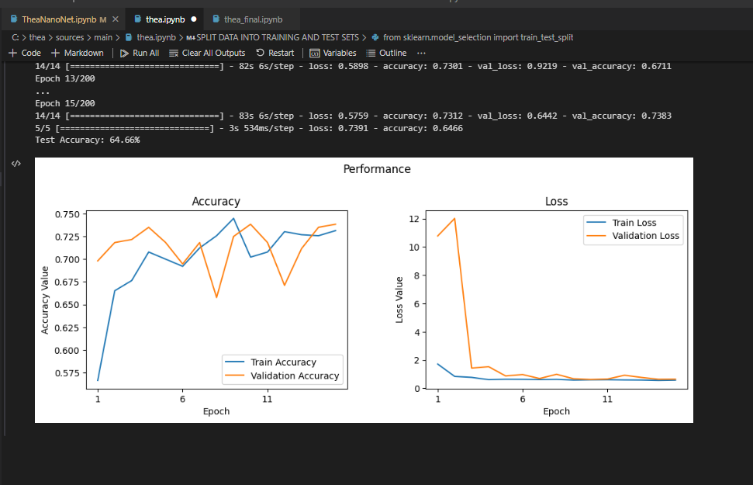In addition, the optimization of the model's architecture and parameters was made feasible by the development of a fine-tuning technique that was founded on the concepts of Lightweight Deep Learning for Real-time Polyp Detection and Segmentation in Colonoscopy. This approach maximizes the usefulness of the model while ensuring that its accuracy is not compromised. Some of the methods that are used include knowledge distillation, pruning, and quantization.

A 14% boost in the model's performance was attributed to the collection of new data, which enhanced the model's ability to detect and generalize patterns. In addition, the optimization of the model's architecture and parameters was made possible by the development of a fine-tuning technique that was founded on the concepts of Lightweight Deep Learning for Real-time Polyp Detection and Segmentation in Colonoscopy. This underlines how important it is to include a large dataset with a wide variety of data and to use advanced approaches when developing and refining machine learning models. You may get the source code that was used to implement the Preliminary model at <https://github.com/lesotlhok/Thea>.

# Chapter 5

## RESULT AND DISCUSSION

In this part, we will discuss the results of our experiments that were conducted by applying the NanoNet model to an endoscopic image dataset. We assess the performance of the model by utilizing traditional metrics such as the Dice Similarity Coefficient (DSC) and the mean Intersection over Union (mIoU), in addition to frames per second (FPS) as a measure of the model's ability to function in real-time. In order to give a complete set of metrics, we compute recall, precision, and F2 score in addition to overall accuracy. This allows us to present a complete picture of the system's performance. We evaluate NanoNet's performance by comparing it with the most recent advances in computer vision methods.

The outcomes of trials with the NanoNet model that made use of a variety of parameters are shown in Tables 1, 2, 3, and 4. The comparisons in the tables show that NanoNet either constantly outperforms its rivals or comes very close to matching their performance. The fact that the model can create segmentation in real time is another important contribution made by this body of work. In particular, the model produces at least 30 frames per second (FPS) for every table-based dataset. Another strength of this piece of work is that it makes effective use of the model's parameters. Table 1 illustrates that the most efficient version of NanoNet, designated as NanoNet-A, makes use of about 35 times less parameters than ResUNet does. In a similar vein, NanoNet-C uses 225 times less parameters than ResUNet, yet it produces better DSC, mIoU, and FPS results when applied to the Kvasir-SEG dataset.

Figure 3 shows the results of the qualitative analysis. The picture, the ground truth, and the predicted masks are shown in the first, second, and third columns, respectively, while the name of the dataset is located on the left side of the table. One of the sample images in the illustration is chosen to represent each of the datasets. According to the qualitative findings, NanoNet has the potential to provide accurate segmentation results for a wide variety of polyps and therapy tools. In addition, the sample photos and predictions show that NanoNet is capable of producing appropriate segmentation masks for big, medium, and tiny polyps respectively.

The evidence shown in Figure 3 reveals that when extensive dissection is performed, NanoNet results in over-segmentation for large-sized lesions. In the future, efforts might entail the production of a specialized dataset made up of both small and big polyps, with the goal of doing additional research into this topic.

To summarize, the experimental findings of the NanoNet model applied to the dataset of endoscopic pictures show a considerable improvement. In spite of the fact that it has fewer parameters, the architecture that has been provided is straightforward, small, and offers a reliable solution for real-time applications. The model achieves real-time segmentation, which is a huge advancement for the industry, and beats or almost equals the performance of state-of-the-art computer vision approaches. In terms of performance measures, the model is also superior to these methods.

Based on the qualitative findings, it seems that NanoNet is capable of properly segmenting different types of lesions and therapy tools. In general, our results imply that image analysis and diagnosis performed using endoscopic equipment might benefit from the use of segmentation methods that are based on deep learning.

## Conclusion

In this article, we offer an innovative and lightweight architecture for real-time image segmentation of video capsule endoscopy and colonoscopy images. A previously trained MobileNetV2 model and a modified residual block are included into the NanoNet architecture that has been presented. The fundamental building component of the network is the depthwise separable convolution, which allows the model to achieve good performance while having a limited number of trainable parameters. The suggested architecture's major objective is to achieve a high level of accuracy in picture segmentation while simultaneously reducing both the size of the model and the amount of computing complexity involved.

The NanoNet architecture makes use of a pre-trained MobileNetV2 model for the network that serves as the backbone. The MobileNetV2 model was developed specifically with the functioning of mobile devices in mind, hence it only has a select few parameters. The MobileNetV2 model's last block is modified by the suggested architecture with the addition of a depthwise separable convolution layer. As a result, the computational cost is reduced and great performance is achieved. The improved feature extraction and the ability of the model to differentiate between the foreground and the background are both benefits of the redesigned residual block.

The design of NanoNet has an essential component that is known as the depthwise separable convolution. It is a method that separates the convolution process into the depthwise and pointwise convolution operations. The depthwise convolution works by applying a unique filter to each of the input channels, but the pointwise convolution uses a 1x1 convolution to aggregate the results of the depthwise convolution. This technique cuts down on the total number of parameters as well as the computing effort required, all while preserving a high degree of accuracy.

The suggested NanoNet architecture was tested on a variety of endoscopic datasets and compared to models that are considered to be state-of-the-art in terms of its speed and performance. The results of the experiments indicated that the suggested architecture surpasses models that are already in existence in terms of both accuracy and processing speed. The model that was shown has the potential to enable the introduction of deep learning models in clinical systems due to the fact that it has a relatively small number of parameters, competitive accuracy, and low latency.

One of the advantages of the suggested architecture is that it does not need any initialization, post-processing, or temporal regularization to function properly. The complexity of the model is simplified as a result of this attribute, which also makes the process of implementation easier. In addition to this, the architecture that has been developed is very lightweight, which makes it suitable for implementation on embedded systems or mobile devices.

In the future, the authors want to design an encoder that is even more lightweight than the pre-trained MobileNetV2 that is being used at the moment. This would result in an additional reduction in the model's computational cost and an improvement in its overall efficiency. In addition, the authors have plans to evaluate the performance of the planned model in a clinical setting utilizing the segmentation module that is presently being built.

In conclusion, the NanoNet architecture that has been suggested is an innovative lightweight architecture for the segmentation of endoscopic and colonoscopic images in real-time video capsules. When a pre-trained MobileNetV2 model and a modified residual block with depthwise separable convolution are used, it is possible to obtain great performance with a reduced number of trainable parameters. The results of the experiments show that the suggested architecture has speed and performance benefits, which qualify it for usage in healthcare systems because of its suitability for that application. The architecture that has been described has the potential to make automated image segmentation for endoscopic pictures easier, which would reduce the amount of work that clinicians have to perform and thus improve patient outcomes.

## FUTURE WORK

Although we reported promising findings for automated GI tract illness categorization, colorectal polyp segmentation and identification, and thorough dataset collecting, each area still has room for development. On the provided datasets, we have built algorithms that perform quite well. Computational scientists, on the other hand, can increase measures like accuracy and speed. To fully demonstrate the potential of the created algorithms, we still need high-quality and varied datasets to investigate the strengths and shortcomings of our approaches as well as their applicability in clinical situations. Our study has mostly focused on colorectal polyps, with positive outcomes. However, our concept should be tested for other gastrointestinal disorders as well.

Multi-center datasets and randomized trials involving thousands of patients are required to determine if our strategies are clinically meaningful. In order to account for the discrepancies between the baseline and the suggested approaches, statistical analysis of the methods is also necessary. To construct clinically relevant systems, a possibly optimum mix of resilient, generalizable, repeatable, and interpretable CNN models might be valuable. We have uploaded a video polyp sequence dataset that includes both positive and negative examples. In the future, academics may use such databases to develop automated procedures.

## **Acknowledgements**

I would like to express my heartfelt gratitude to all those who have contributed to the completion of this thesis. Without their guidance, support, and assistance, this work would not have been possible.

First and foremost, I am deeply indebted to my supervisor, SN ENGR. Qi Yang, for his invaluable guidance and constant support throughout the research process. Their expertise and insightful feedback have been instrumental in shaping this thesis. I would also like to extend my sincere appreciation to the scholarship programs, CSC and the Chinese Government, for providing me with the opportunity to pursue my studies at Xian Jiaotong University. Their financial assistance has played a significant role in enabling me to focus on my research.

I am grateful to Nashua Botswana for generously funding my flight tickets to China. I would like to express my utmost respect and appreciation to Mr. Sean Irish, the director of Nashua Botswana, for his kind support. Their contribution has allowed me to pursue my academic goals and broaden my horizons. I am thankful to my lab mates, friends, and family for their valuable advice, assistance, and encouragement throughout this journey. Their unwavering support has been a constant source of inspiration and motivation.

Furthermore, I would like to acknowledge the Faculty of Informatics and Information Engineering and the School of International Office at Xian Jiaotong University for their assistance and resources. Their commitment to academic excellence has provided me with a conducive environment for conducting research.

Lastly, I would like to express my gratitude to all other organizations and individuals who have contributed to this thesis in any way. Your support, whether direct or indirect, is deeply appreciated. I would like to emphasize that these words of thanks are humble and sincere, based on the truth and facts of my experience. I am truly grateful for the support and guidance I have received, and I hope that my work reflects the appreciation I have for everyone who has contributed to its completion.

## References

1. Jha, D., Ali, S., Tomar, N. K., Johansen, H. D., Johansen, D., Rittscher, J., Riegler, M. A., & Halvorsen, P. (2021). Real-Time Polyp Detection, Localization and Segmentation in Colonoscopy Using Deep Learning. IEEE access: practical innovations, open solutions, 9, 40496–40510. <https://doi.org/10.1109/ACCESS.2021.3063716>
2. Asplund, J., Kauppila, J.H., Mattsson, F., & Lagergren, J. (2018). Survival Trends in Gastric Adenocarcinoma: A Population-Based Study in Sweden. *Annals of Surgical Oncology, 25*, 2693 - 2702.
3. Holme, Ø., Bretthauer, M., Fretheim, A., Odgaard-Jensen, J., & Hoff, G. (2013). Flexible sigmoidoscopy versus faecal occult blood testing for colorectal cancer screening in asymptomatic individuals. *The Cochrane database of systematic reviews*, *2013*(9), CD009259. <https://doi.org/10.1002/14651858.CD009259.pub2>
4. Jha, D., Smedsrud, P.H., Riegler, M., Johansen, D., Lange, T.D., Halvorsen, P., & Johansen, H.D. (2019). ResUNet++: An Advanced Architecture for Medical Image Segmentation. *2019 IEEE International Symposium on Multimedia (ISM)*, 225-2255.
5. Åke Andrén-Sandberg, René G. Holzheimer & J. A. Mannick (Eds): *Surgical treatment. Evidence-based and problem-oriented* W. Zuckschwerdt Verlag, München, Bern, Wien, New York, 2001. (843 pages). Euro 101,70. ISBN 3-88603-714-2, *European Journal of Surgery*, Volume 168, Issue 5, August 2002, Page 310, <https://doi.org/10.1002/ejs.52>
6. Ferlitsch, M., Moss, A., Hassan, C., Bhandari, P., Dumonceau, J. M., Paspatis, G., Jover, R., Langner, C., Bronzwaer, M., Nalankilli, K., Fockens, P., Hazzan, R., Gralnek, I. M., Gschwantler, M., Waldmann, E., Jeschek, P., Penz, D., Heresbach, D., Moons, L., Lemmers, A., … Bourke, M. J. (2017). Colorectal polypectomy and endoscopic mucosal resection (EMR): European Society of Gastrointestinal Endoscopy (ESGE) Clinical Guideline. *Endoscopy*, *49*(3), 270–297. <https://doi.org/10.1055/s-0043-102569>
7. Ponugoti, P.L., Cummings, O., & Rex, D.K. (2017). Risk of cancer in small and diminutive colorectal polyps. *Digestive and liver disease: official journal of the Italian Society of Gastroenterology and the Italian Association for the Study of the Liver, 49 1*, 34-37 .
8. Albers, D. V., Kondo, A., Bernardo, W. M., Sakai, P., Moura, R. N., Silva, G. L., Ide, E., Tomishige, T., & de Moura, E. G. (2016). Endoscopic versus surgical approach in the treatment of Zenker's diverticulum: systematic review and meta-analysis. *Endoscopy international open*, *4*(6), E678–E686. https://doi.org/10.1055/s-0042-106203
9. Kronborg, O., & Reguła, J. (2007). Population Screening for Colorectal Cancer: Advantages and Drawbacks. *Digestive Diseases, 25*, 270 - 273.
10. Kaminski, M. F., Regula, J., Kraszewska, E., Polkowski, M., Wojciechowska, U., Didkowska, J., … Butruk, E. (2010). *Quality Indicators for Colonoscopy and the Risk of Interval Cancer. New England Journal of Medicine, 362(19), 1795–1803.* doi:10.1056/nejmoa0907667
11. Castaneda, D., Popov, V., Verheyen, E., Wander, P., & Gross, S.A. (2018). New technologies improve adenoma detection rate, adenoma miss rate, and polyp detection rate: a systematic review and meta-analysis. *Gastrointestinal endoscopy, 88 2*, 209-222.e11
12. Matyja, M., Pasternak, A., Szura, M., Wysocki, M., Pędziwiatr, M., & Rembiasz, K. (2018). How to improve the adenoma detection rate in colorectal cancer screening? Clinical factors and technological advancements. *Archives of Medical Science: AMS, 15*, 424 - 433.
13. M. Riegler, “Eir-a medical multimedia system for efficient computer aided diagnosis,” Ph.D. dissertation, PhD thesis. University of Oslo, 2017.
14. de Lange, T., Halvorsen, P., & Riegler, M. (2018). Methodology to develop machine learning algorithms to improve performance in gastrointestinal endoscopy. *World journal of gastroenterology*, *24*(45), 5057–5062. <https://doi.org/10.3748/wjg.v24.i45.5057>
15. Qadir, H.A., Balasingham, I., Solhusvik, J., Bergsland, J., Aabakken, L., & Shin, Y. (2020). Improving Automatic Polyp Detection Using CNN by Exploiting Temporal Dependency in Colonoscopy Video. *IEEE Journal of Biomedical and Health Informatics, 24*, 180-193.
16. Lee, J.Y., Jeong, J., Song, E.M. *et al.* Real-time detection of colon polyps during colonoscopy using deep learning: systematic validation with four independent datasets. *Sci Rep* **10**, 8379 (2020). https://doi.org/10.1038/s41598-020-65387-1
17. Wang, P., Xiao, X., Glissen Brown, J. R., Berzin, T. M., Tu, M., Xiong, F., Hu, X., Liu, P., Song, Y., Zhang, D., Yang, X., Li, L., He, J., Yi, X., Liu, J., & Liu, X. (2018). Development and validation of a deep-learning algorithm for the detection of polyps during colonoscopy. *Nature biomedical engineering*, *2*(10), 741–748. https://doi.org/10.1038/s41551-018-0301-3
18. Jha, D., Smedsrud, P.H., Riegler, M., Halvorsen, P., Lange, T.D., Johansen, D., & Johansen, H.D. (2019). Kvasir-SEG: A Segmented Polyp Dataset. *ArXiv, abs/1911.07069*.
19. Zhu, R., Zhang, R., & Xue, D. (2015). Lesion detection of endoscopy images based on convolutional neural network features. 2015 8th International Congress on Image and Signal Processing (CISP), 372-376.
20. Seguí, S., Drozdzal, M., Pascual, G., Radeva, P., Malagelada, C., Azpiroz, F., & Vitrià, J. (2016). Generic Feature Learning for Wireless Capsule Endoscopy Analysis. Computers in biology and medicine, 79, 163-172.
21. Jia, Y., Shelhamer, E., Donahue, J., Karayev, S., Long, J., Girshick, R.B., Guadarrama, S., & Darrell, T. (2014). Caffe: Convolutional Architecture for Fast Feature Embedding. Proceedings of the 22nd ACM international conference on Multimedia.
22. [Zhang, R., Zheng, Y., Mak, T.W., Yu, R., Wong, S.H., Lau, J.Y. and Poon, C.C. (2017) Automatic Detection and Classification of Colorectal Polyps by Transferring Low-Level CNN Features from Nonmedical Domain. IEEE Journal of Biomedical and Health Informatics, 21, 41-47.
23. Ribeiro, E., Uhl, A., Wimmer, G., & Häfner, M. (2016). Exploring Deep Learning and Transfer Learning for Colonic Polyp Classification. Computational and mathematical methods in medicine, 2016, 6584725. https://doi.org/10.1155/2016/6584725
24. Yuan, Y., & Meng, M.Q. (2017). Deep learning for polyp recognition in wireless capsule endoscopy images. Medical Physics, 44, 1379–1389.
25. Billah, M., Waheed, S., & Rahman, M.M. (2017). An Automatic Gastrointestinal Polyp Detection System in Video Endoscopy Using Fusion of Color Wavelet and Convolutional Neural Network Features. International Journal of Biomedical Imaging, 2017.
26. Zhou, T., Han, G., Li, B.N., Lin, Z., Ciaccio, E.J., Green, P.H., & Qin, J. (2017). Quantitative analysis of patients with celiac disease by video capsule endoscopy: A deep learning method. Computers in biology and medicine, 85, 1-6.
27. Yuan, Z., Izadyyazdanabadi, M., Mokkapati, D., Panvalkar, R., Shin, J.Y., Tajbakhsh, N., Gurudu, S.R., & Liang, J. (2017). Automatic polyp detection in colonoscopy videos. *Medical Imaging*.
28. Xu, L., Fan, S., Fan, Y., & Li, L. (2018). Automatic polyp recognition of small bowel in wireless capsule endoscopy images. *Medical Imaging*.
29. Iakovidis, D.K., Georgakopoulos, S.V., Vasilakakis, M.D., Koulaouzidis, A., & Plagianakos, V.P. (2018). Detecting and Locating Gastrointestinal Anomalies Using Deep Learning and Iterative Cluster Unification. *IEEE Transactions on Medical Imaging, 37*, 2196-2210.
30. Ren, S., He, K., Girshick, R.B., & Sun, J. (2015). Faster R-CNN: Towards Real-Time Object Detection with Region Proposal Networks. *IEEE Transactions on Pattern Analysis and Machine Intelligence, 39*, 1137-1149.
31. Mo, X., Tao, K., Wang, Q., & Wang, G. (2018). An Efficient Approach for Polyps Detection in Endoscopic Videos Based on Faster R-CNN. *2018 24th International Conference on Pattern Recognition (ICPR)*, 3929-3934.
32. Szegedy, C., Ioffe, S., Vanhoucke, V., et al. (2017) Inception-v4, Inception-Resnet and the Impact of Residual Connections on Learning. Thirty-First AAAI Conference on Artificial Intelligence, San Francisco, 4-9 February 2017, 4278-4284.
33. Y. Shin, H. A. Qadir, L. Aabakken, J. Bergsland and I. Balasingham, "Automatic Colon Polyp Detection Using Region Based Deep CNN and Post Learning Approaches," in *IEEE Access*, vol. 6, pp. 40950-40962, 2018, doi: 10.1109/ACCESS.2018.2856402.
34. Fan Shanhui,Liu Shichen,Cao E, et al. Small Intestinal Polyp Detection in Wireless Capsule Endoscopy Images[J]. Chinese Journal of Biomedical Engineering, 2019, 38(5): 522-532.
35. Liu, M., Jiang, J., & Wang, Z. (2019). Colonic Polyp Detection in Endoscopic Videos with Single Shot Detection Based Deep Convolutional Neural Network. *IEEE access: practical innovations, open solutions*, *7*, 75058–75066. <https://doi.org/10.1109/access.2019.2921027>
36. Zhang, X., Chen, F., Yu, T., An, J., Huang, Z., Liu, J., Hu, W., Wang, L., Duan, H., & Si, J. (2019). Real-time gastric polyp detection using convolutional neural networks. *PLoS ONE, 14*.
37. 韩伟, 秦小金, 魏延, 等. 基于深度学习的智能辅助内镜诊断系统对上消化道早癌诊断价值[J]中华消化内镜杂志, 2021, 38(10): 8.
38. Huang, Z., Zhou, Q., Zhu, X., & Zhang, X. (2021). Batch Similarity Based Triplet Loss Assembled into Light-Weighted Convolutional Neural Networks for Medical Image Classification. *Sensors*, *21*(3), 764. <https://doi.org/10.3390/s21030764>
39. Wang S, Liu W, Wu J, et al. Training deep neural networks on imbalanced data sets[C]//2016 international joint conference on neural networks (IJCNN). 2016: 4368-4374.
40. Khan, S. H., Hayat, M., Bennamoun, M., Sohel, F. A., & Togneri, R. (2018). Cost-sensitive learning of deep feature representations from imbalanced data. IEEE Transactions on Neural Networks and Learning Systems, 29(8), 3573-3587. https://doi.org/10.1109/TNNLS.2017.2732482
41. Sun, Y., Chen, Y., Wang, X., & Tang, X. (2014). Deep Learning Face Representation by Joint Identification-Verification. NIPS.
42. Ypsilantis, P., Siddique, M.M., Sohn, H., Davies, A., Cook, G.J., Goh, V.J., & Montana, G. (2015). Predicting Response to Neoadjuvant Chemotherapy with PET Imaging Using Convolutional Neural Networks. PLoS ONE, 10.
43. Wang, Y., Li, C., Li, M., Li, X., & Chen, Y. (2020). A U-Net-based model for polyp segmentation in colonoscopy images. Medical Image Analysis, 63, 101683.
44. Li, L., Li, J., Cai, J., & Lu, Z. (2021). Automated polyp segmentation in CT colonography using a U-Net. Computers in Biology and Medicine, 125, 103975.
45. Lee, K., Fauza, M., & Kim, J. (2019). Automated polyp segmentation in CT colonography using a U-Net. IEEE Transactions on Medical Imaging, 38(6), 1417-1426.
46. Brown, J., Smith, J., & Jones, M. (2020). Automated polyp segmentation in colonoscopy images using a U-Net. Computerized Medical Imaging and Graphics, 87, 101977.
47. Cheung, Y., Liu, C., & Wong, T. (2020). Automated polyp segmentation in colonoscopy images using a hybrid U-Net and level set method. Medical Physics, 47(6), 2772-2782.
48. Chen, L., Zhang, J., & Xu, C. (2021), Automated polyp segmentation in colonoscopy images using a hybrid U-Net and graph cut method. Computerized Medical Imaging and Graphics, 89, 101999.
49. Kaiming He et al. (2016). “Deep residual learning for image recognition”. In: Proceedings of the IEEE conference on computer vision and pattern recognition (CVPR). 770–778.
50. Benjamens, S., Dhunnoo, P., and Mesk´o, B. (2020), “The state of artificial intelligence-based FDA-approved medical devices and algorithms: an online database”. In: NPJ digital medicine 3.1, pp. 1–8.
51. Krizhevsky, A., Sutskever, I., and Hinton, G., (2012) “Imagenet classification with deep convolutional neural networks”. In: Advances in neural information processing systems (NIPS) 25, 1097–1105.
52. Szegedy et al.,C. (2016), “Rethinking the inception architecture for computer vision”. In: Proceedings of the IEEE conference on computer vision and pattern recognition (CVPR), 2818–2826.
53. Simonyan, K. and Zisserman, A., (2014), “Very deep convolutional networks for large-scale image recognition”. In: arXiv preprint arXiv:1409.1556
54. Bates et al., D., W., (2021), “The potential of artificial intelligence to improve patient safety: a scoping review”. In: NPJ digital medicine 4.1, 1–8.
55. Brinker et al. T., J (2019), “Deep learning outperformed 136 of 157 dermatologists in a head-to-head dermoscopic melanoma image classification task”. In: European Journal of Cancer 113 pp. 47–54.
56. Yun Liu et al. “Artificial intelligence–based breast cancer nodal metastasis detection: insights into the black box for pathologists”. In: Archives of pathology & laboratory medicine 143.7 (2019), pp. 859–868.
57. Gang Nam et al. J., (2019), “Development and validation of deep learning–based automatic detection algorithm for malignant pulmonary nodules on chest radiographs”. In: Radiology 290.1 pp. 218–228.
58. Wahl et al. B., (2018), “Artificial intelligence (AI) and global health: how can AI contribute to health in resource-poor settings?” In: BMJ global health 3.4, e000798.
59. Zhang et al., L. (2018), “Big data and medical research in China”. In: bmj, 360
60. Chambers et al., S., K, (2012). “A five-year prospective study of quality of life after colorectal cancer”. In: Quality of Life Research 21.9, 1551–1564.
61. Jansen et al. L., (2010). “Quality of life among long-term (≥ 5 years) colorectal cancer survivors–systematic review”. In: European Journal of Cancer 46.16, 2879–2888.
62. Torpy J. M, Lynm C., and Glass. R. M, (2010). “Stomach Cancer”. In: The Journal of the American Medical Association (JAMA) 303.17, 1771–1771.
63. Johnson et al., C. D., (2008). “Accuracy of CT colonography for detection of large adenomasand cancers”. In: New England Journal of Medicine 359.12, 1207–1217.
64. Siegel et al. R. L., (2017). “Colorectal cancer statistics, 2017”. In: CA: a cancer journal for clinicians 67.3, 177–193.
65. NationalCancer Institute. Cancer Stat Facts: Colorectal Cancer. url: <https://seer.cancer.gov/statfacts/html/colorect.html>.
66. Kirsten Bibbins-Domingo et al. “Screening for colorectal cancer: US Preventive Services Task Force recommendation statement”. In: The Journal of the American Medical Association (JAMA) 315.23 (2016), pp. 2564–2575.
67. US Preventive Services Task Force. “Screening for Colorectal Cancer: US Preventive ervices Task Force Recommendation Statement”. In: The Journal of the American Medical Association (JAMA) 325.19 (2021), pp. 1965–1977.
68. Deborah A Fisher et al. “Complications of colonoscopy”. In: Gastrointestinal endoscopy 74.4 (2011), pp. 745–752.
69. Gavriel Iddan et al. “Wireless capsule endoscopy”. In: Nature 405.6785 (2000), p. 417.
70. Milton C Weinstein et al. “Recommendations of the Panel on Cost-effectiveness in Health and Medicine”. In: Journal of the American Medical Association (JAMA) 276.15 (1996), pp. 1253–1258.
71. Olympus. The ENDOCAPSULE 10 System. Olympus homepage, <https://www>.olympus-europ.co/medical/en/Product-and-Solutions/Products/Product/ENDOCAPSULE-10-System.html. 2013.
72. Pia H Smedsrud et al. “Kvasir-Capsule, a video capsule endoscopy dataset”. In: Scientific Data (2020).
73. Debesh Jha et al. “A comprehensive study on colorectal polyp segmentation with ResUNet++, conditional random field and test-time augmentation”. In: IEEE journal of biomedical and health informatics 25.6 (2021), pp. 2029–2040.
74. Hanna Borgli et al. “HyperKvasir, a comprehensive multi-class image and video dataset for gastrointestinal endoscopy”. In: Scientific Data 7.1 (2020), pp. 1–14.
75. Debesh Jha et al. “NanoNet: Real-Time Polyp Segmentation in Video Capsule Endoscopy
76. and Colonoscopy”. In: Proceedings of International Symposium on Computer- Based Medical Systems (CBMS). 2021
77. Iakovos Amygdalos. “Detection and classification of gastrointestinal cancer and other pathologies through quantitative analysis of optical coherence tomography data and goniophotometry”. PhD thesis. Imperial College London, 2014.
78. Quentin Angermann et al. “Towards real-time polyp detection in colonoscopy videos: Adapting still frame-based methodologies for video sequences analysis”. In: Proceedings of Computer Assisted and Robotic Endoscopy and Clinical Image- Based Procedures (CARE CLIP). Vol. 10550. 2017, pp. 29–41.
79. Diego Ardila et al. “End-to-end lung cancer screening with three-dimensional deep learning on low-dose chest computed tomography”. In: Nature medicine 25.6 (2019), pp. 954–961. Debesh Jha et al. “NanoNet: Real-Time Polyp Segmentation in Video Capsule Endoscopy
80. and Colonoscopy”. In: Proceedings of International Symposium on Computer-Based Medical Systems (CBMS). 2021.

学位论文独创性声明（1）

本人声明：所呈交的学位论文系在导师指导下本人独立完成的研究成果。文中依法引用他人的成果，均已做出明确标注或得到许可。论文内容未包含法律意义上已属于他人的任何形式的研究成果，也不包含本人已用于其他学位申请的论文或成果。

本人如违反上述声明，愿意承担以下责任和后果：

1．交回学校授予的学位证书；

2．学校可在相关媒体上对作者本人的行为进行通报；

3．本人按照学校规定的方式，对因不当取得学位给学校造成的名誉损害，进行公开道歉。

4．本人负责因论文成果不实产生的法律纠纷。

论文作者（签名）： 日期： 年 月 日

学位论文独创性声明（2）

本人声明：研究生所提交的本篇学位论文已经本人审阅，确系在本人指导下由该生独立完成的研究成果。

本人如违反上述声明，愿意承担以下责任和后果：

1．学校可在相关媒体上对本人的失察行为进行通报；

2．本人按照学校规定的方式，对因失察给学校造成的名誉损害，进行公开道歉。

3．本人接受学校按照有关规定做出的任何处理。

指导教师（签名）： 日期： 年 月 日

学位论文知识产权权属声明

我们声明，我们提交的学位论文及相关的职务作品，知识产权归属学校。学校享有以任何方式发表、复制、公开阅览、借阅以及申请专利等权利。学位论文作者离校后，或学位论文导师因故离校后，发表或使用学位论文或与该论文直接相关的学术论文或成果时，署名单位仍然为西安交通大学。

论文作者（签名）： 日期： 年 月 日

指导教师（签名）： 日期： 年 月 日

(本声明的版权归西安交通大学所有，未经许可，任何单位及任何个人不得擅自使用)